



**Department of Computer Science and Engineering**

**PROJECT REPORT**

**Project Title:**

*Food Waste Reduction and Donation Management System by WasteToWorth*

|  |  |
| --- | --- |
| **Student(s) Name:** | **Ameer Hamzah Daiyan (C231185)**  **Mohammad Junaid Mahmud (C231189)**  B. Sc. in CSE  Department of Computer Science and Engineering (CSE)  International Islamic University, Chittagong. |
| **Teacher:** | **Md. Warid Bin Azad**  Adjunct Lecturer,  Department of CSE, IIUC. |

**Approval of the Teacher**

**_______________________**

Md. Warid Bin Azad

Adjunct Lecturer,

Department of CSE, IIUC.

**Food Waste Reduction and Donation Management System**

***Introduction:***

Food waste is a critical global issue, contributing to environmental, economic, and social challenges. The “**WasteToWorth”** aims to bridge the gap between surplus food and charitable needs, optimizing resource allocation while minimizing food wastage. This system streamlines inventory tracking, donation management, supplier coordination, and reporting, providing a comprehensive solution for efficient food distribution. By integrating advanced SQL database management, the project facilitates real-time data management for inventory, donations, and supply chain activities. The platform ensures transparency, enhances decision-making, and supports charitable organizations in receiving timely assistance. This solution not only promotes sustainability but also fosters a collaborative approach toward reducing hunger and food waste.

***Literature Review:***

|  |  |  |
| --- | --- | --- |
| **Existing works and URLs** | **Findings** | **Effects / My Observation** |
| * Feeding America’s MealConnect Platform   Link: <https://mealconnect.org/> | The platform has successfully reduced food waste by efficiently matching surplus food with nearby charities. | While effective, MealConnect primarily targets large-scale food donations and lacks detailed inventory management features for suppliers and smaller stores. |

|  |  |  |
| --- | --- | --- |
| * Zero Waste Management System in Supermarkets (Tesco PLC, 2020)   Link: <https://www.tescoplc.com/> | Integrating donation management with inventory systems reduced food waste while supporting local charities. | Tesco’s solution is limited to its stores and does not function as an open platform for multi-store or supplier collaboration. |
| * Food Rescue US: A Community-Based Approach to Food Donation   Link: <https://foodrescue.us/> | Community-driven platforms improve food redistribution efficiency but face challenges in tracking inventory levels and supplier contributions. | Lack of robust reporting and analytics hinders performance monitoring. |

Food waste is a significant global issue with far-reaching implications for food security, environmental sustainability, and economic stability. Numerous studies and existing systems have addressed various facets of food waste reduction, inventory management, and donation systems. This review analyzes current literature, identifies gaps, and presents observations that form the basis for developing the proposed “**Food Waste Reduction and Donation Management System”**.

***Aims & Objectives:***

1. **Optimize Inventory Management:**

Automate tracking of perishable items and identify near-expiry goods to minimize waste.

1. **Streamline Donations:**

Facilitate seamless coordination between food donors and charities for timely redistribution.

1. **Integrate Stores and Suppliers:**

Enhance transparency and streamline surplus inventory sharing between stores and suppliers.

1. **Data-Driven Insights:**

Generate analytical reports on inventory, donations, and waste reduction for informed decision-making.

1. **Improve System Efficiency:**

Implement SQL-based solutions for faster data processing and user-friendly operations.

1. **Promote Sustainability:**

Support eco-friendly food management practices and foster collaboration among stakeholders.

***SQL Queries and Output with Description***

1. **CREATE DATABASE:**

To create the database for managing food waste, donations, and related operations.

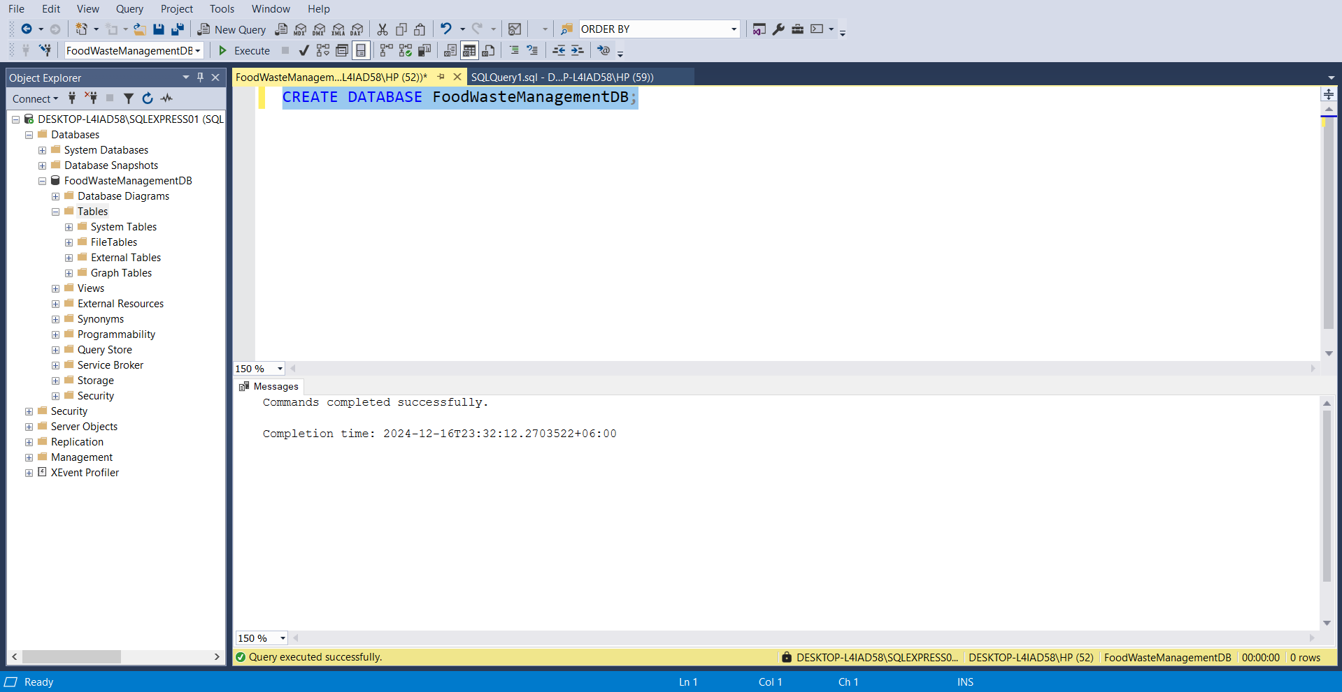

1. **CREATE TABLE:**

Tables like Stores, Inventory, Charities, Donations, Employees, Suppliers, SupplierInventory, DonationRequests, and Reports are created with specific fields and foreign key relationships.

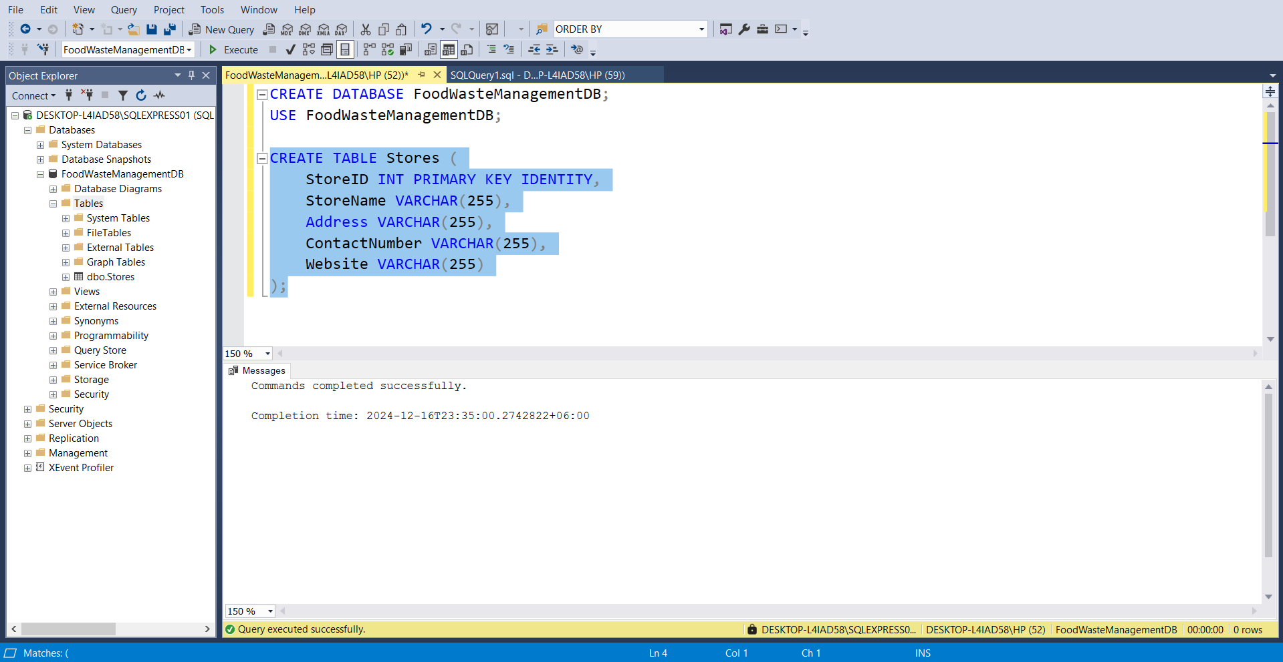

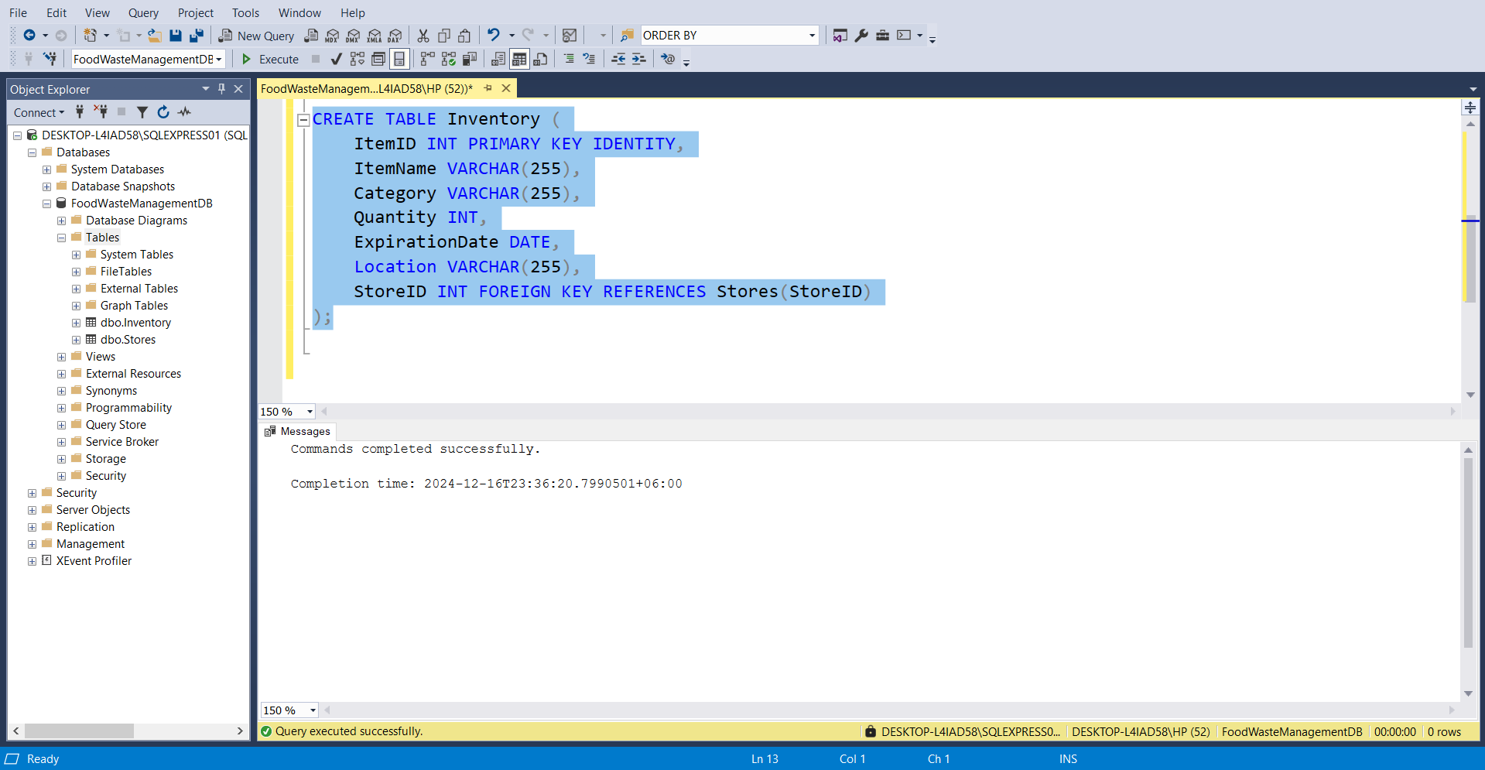

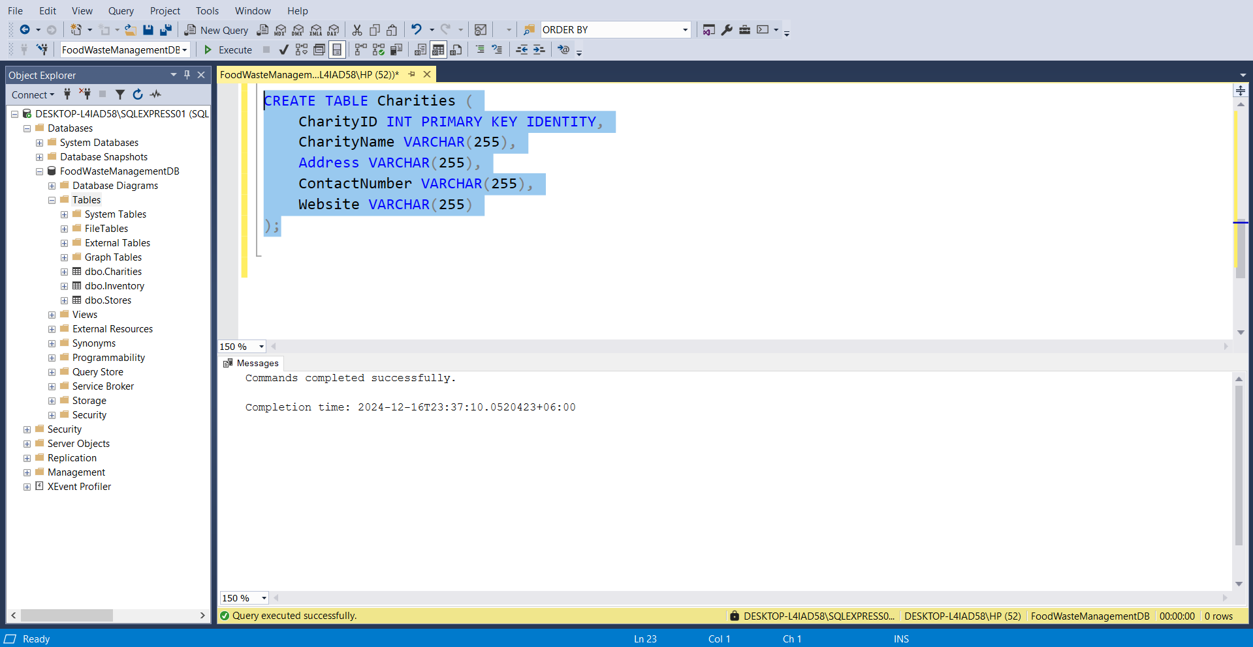

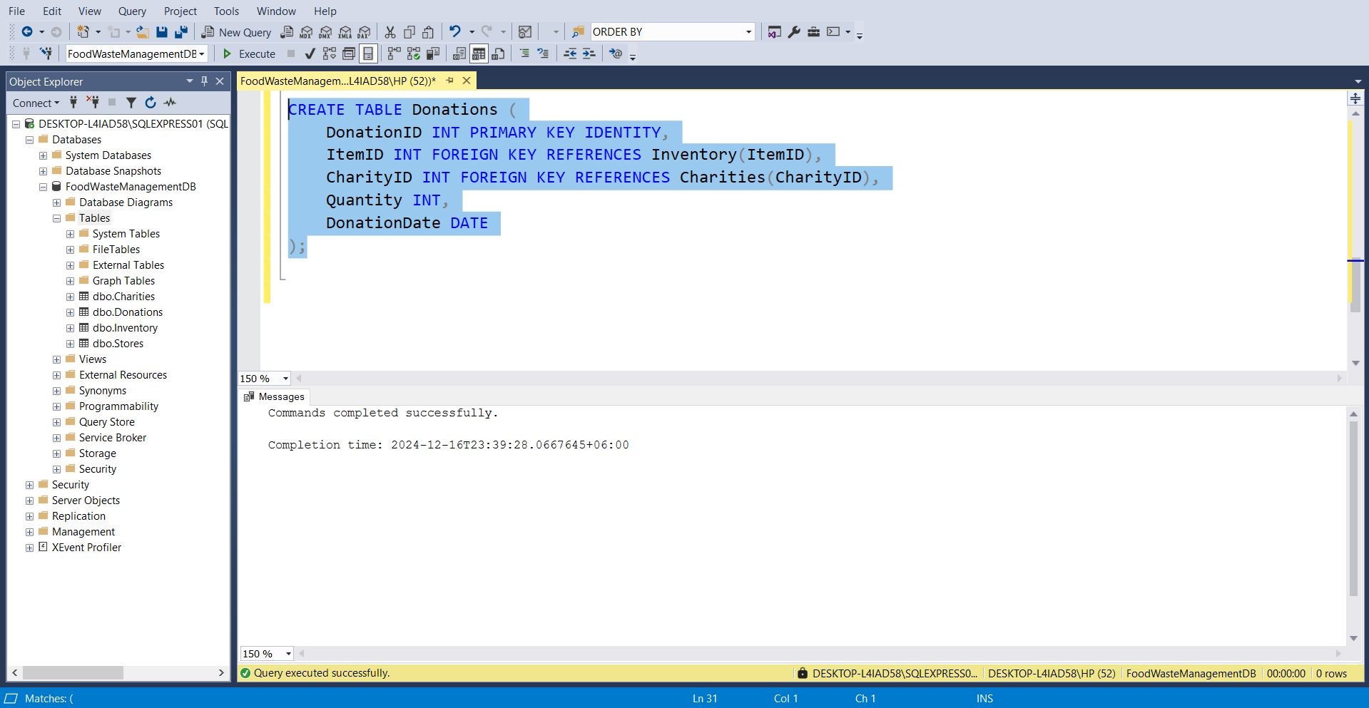

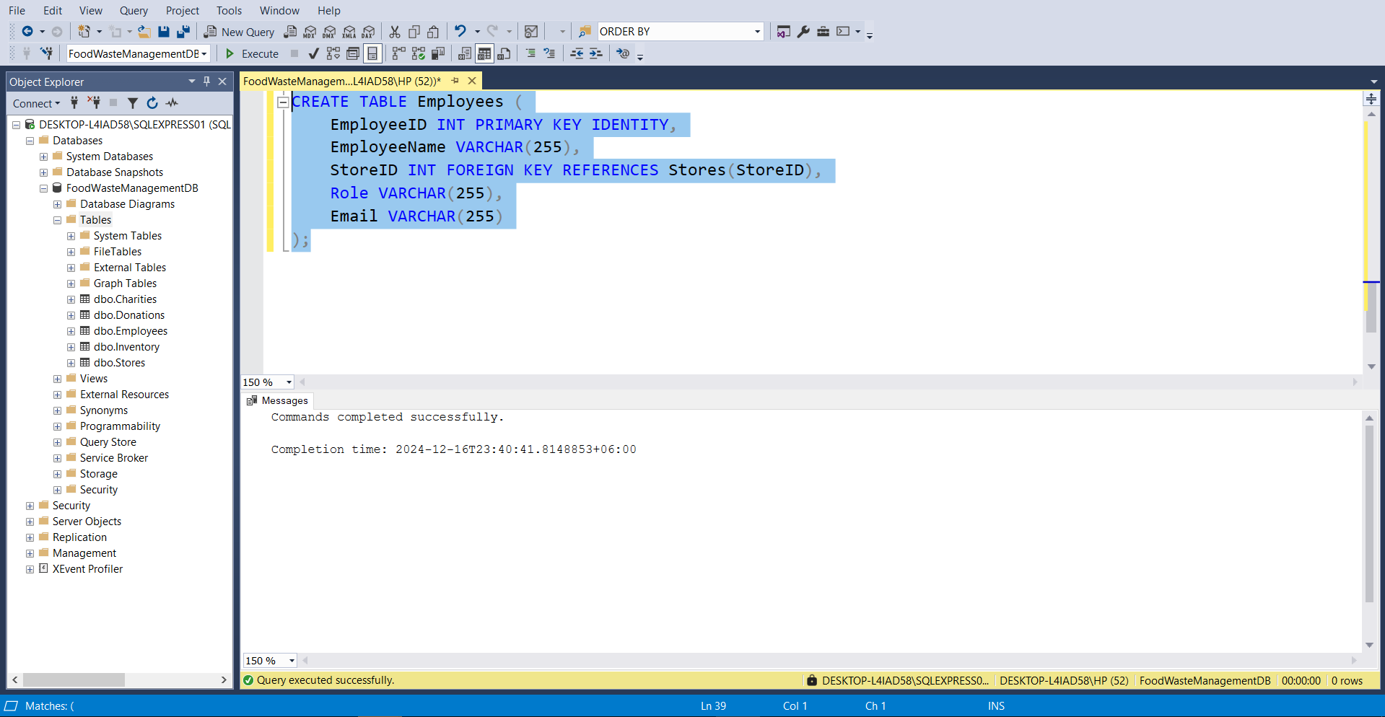

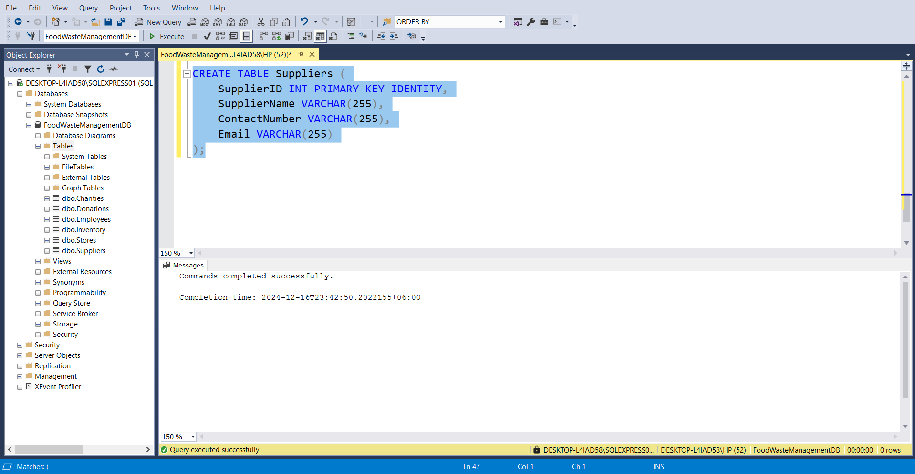

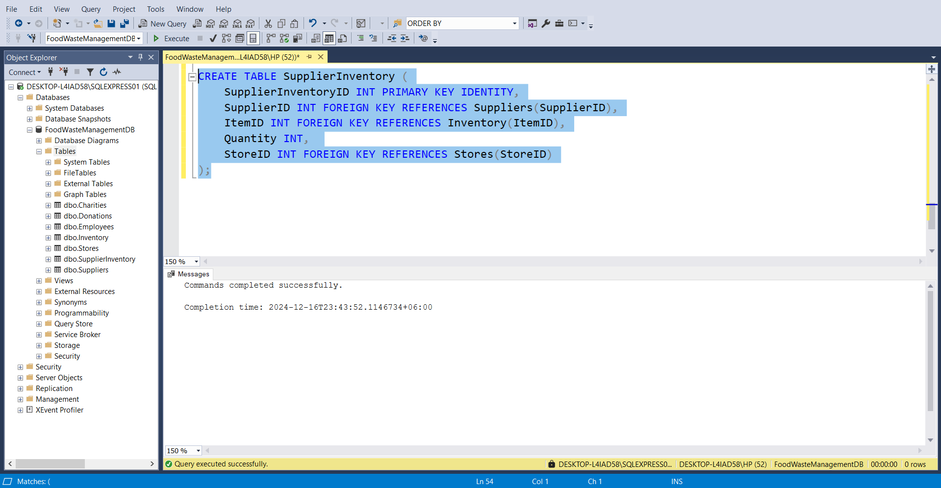

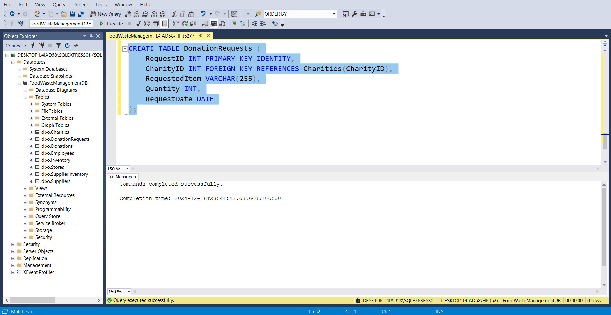

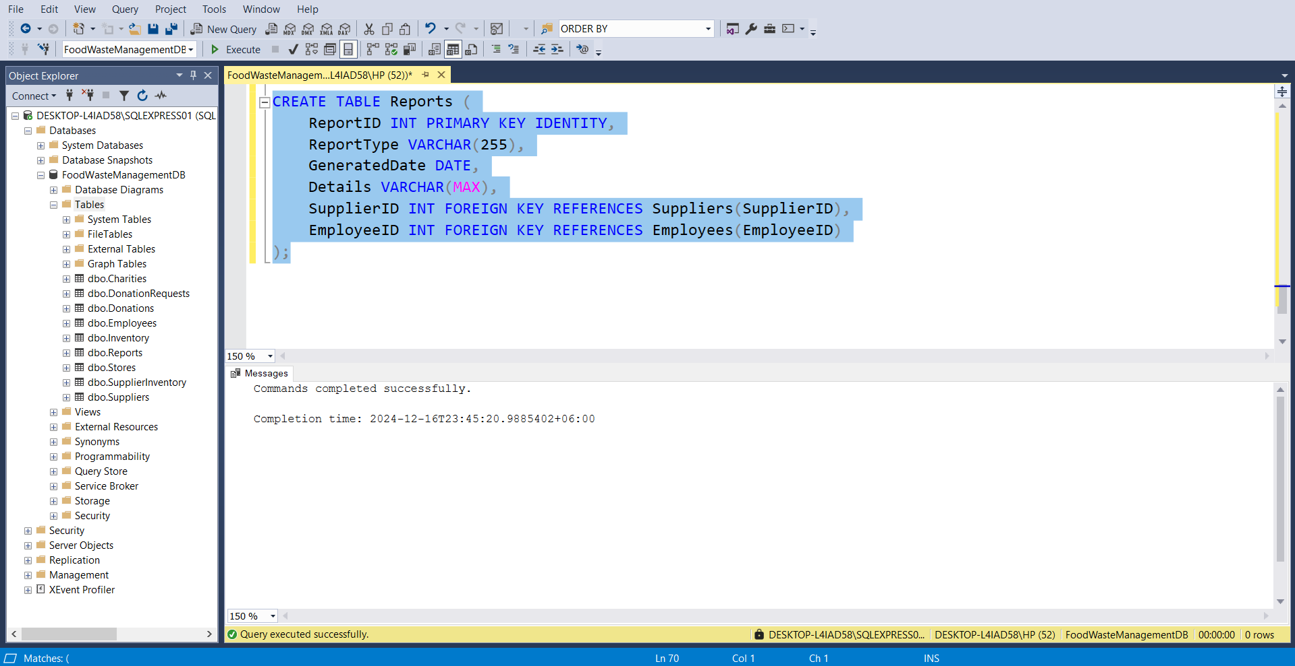

1. **INSERT Query:**

Inserts sample data into tables such as Stores, Inventory, Charities, Donations, Employees, Suppliers, SupplierInventory, DonationRequests, and Reports.

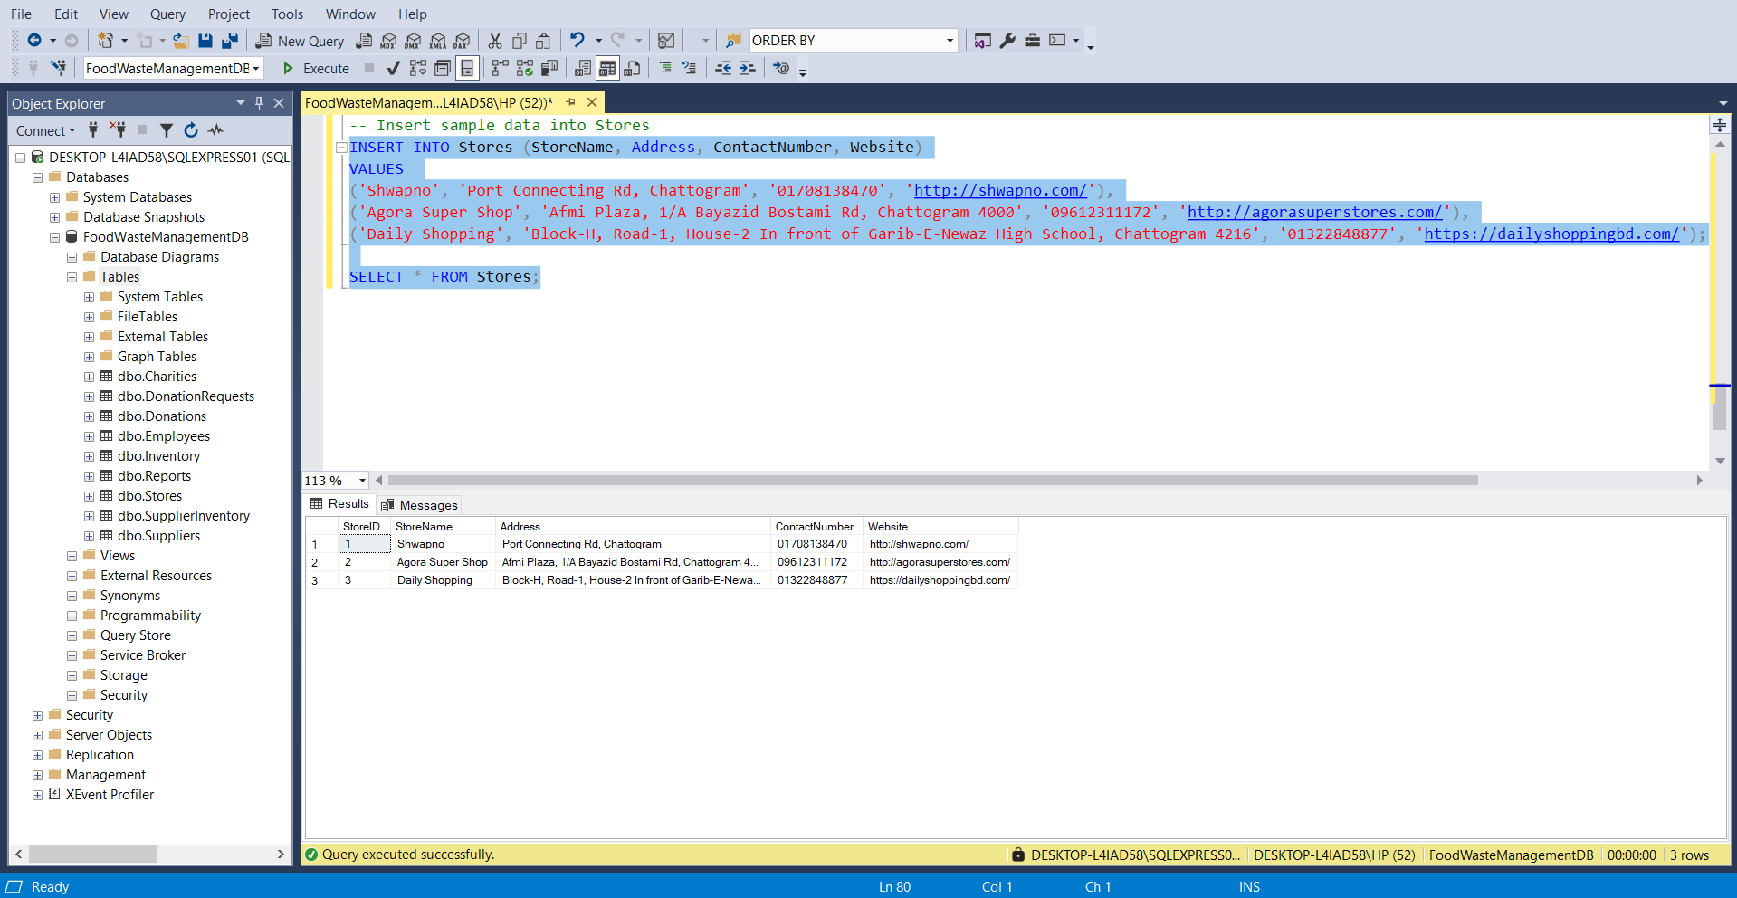

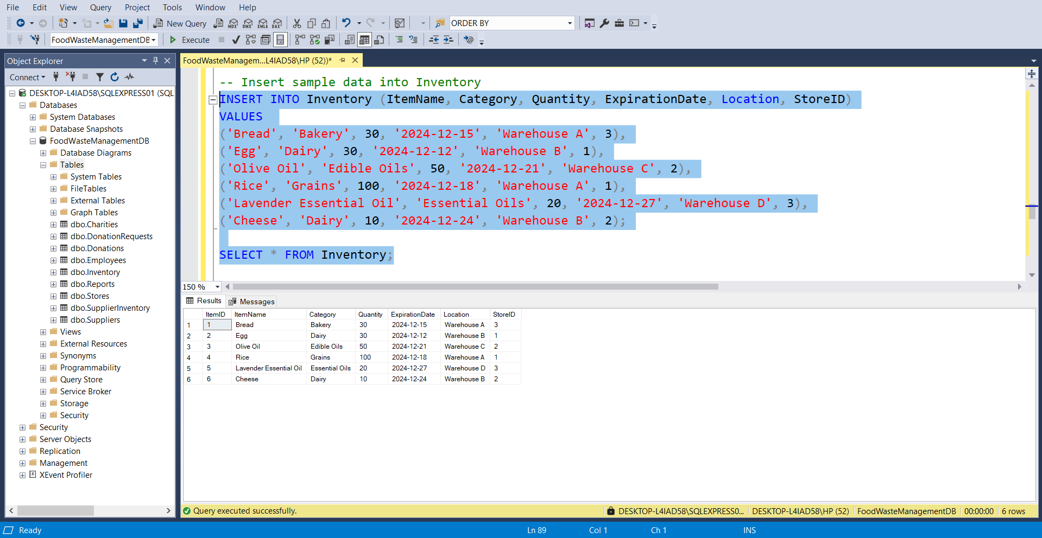

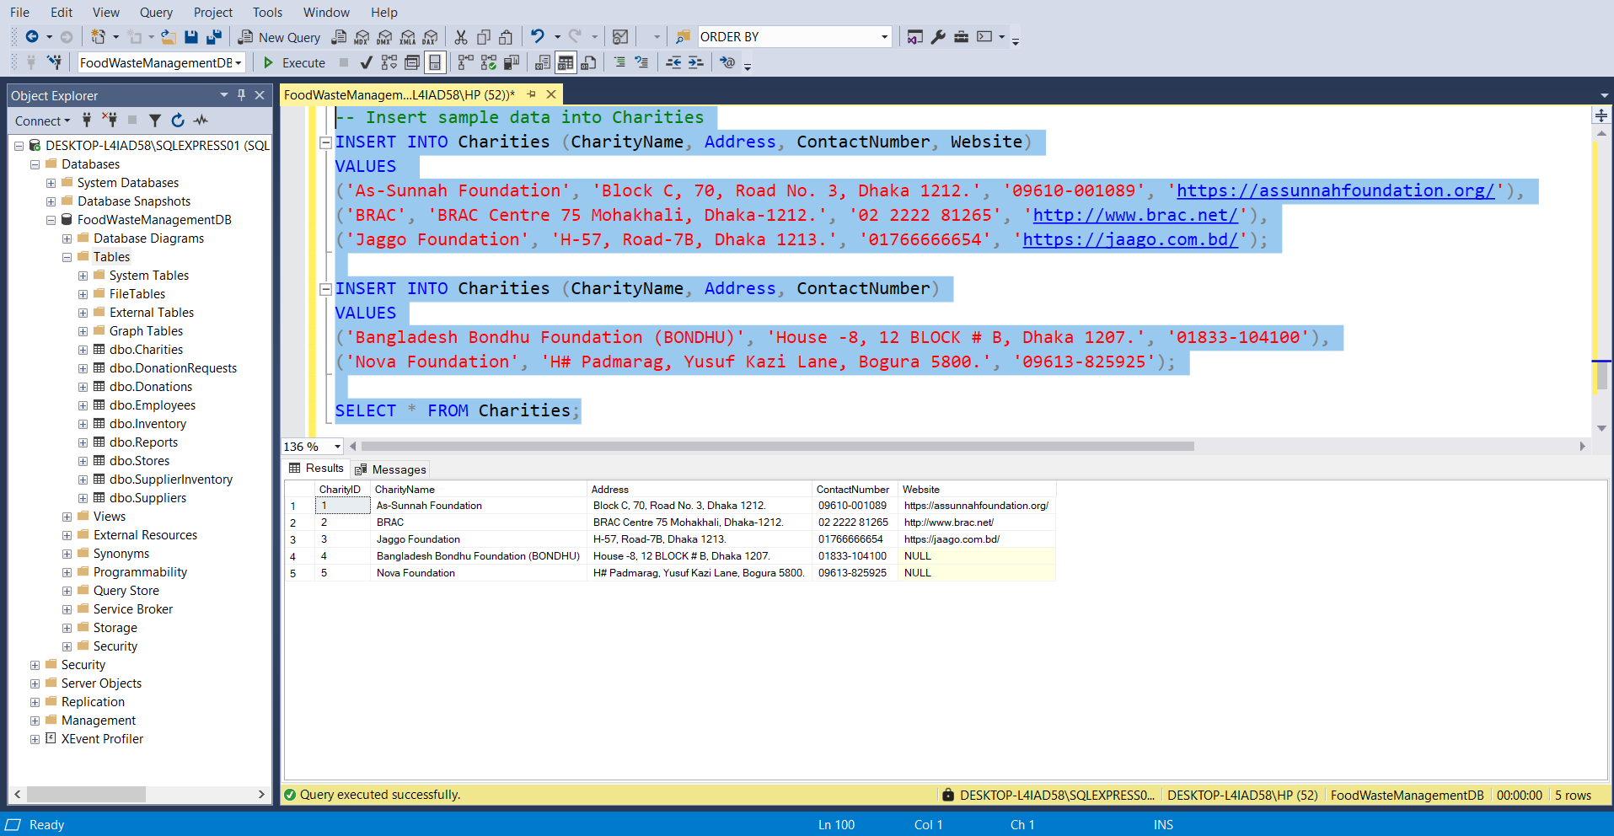

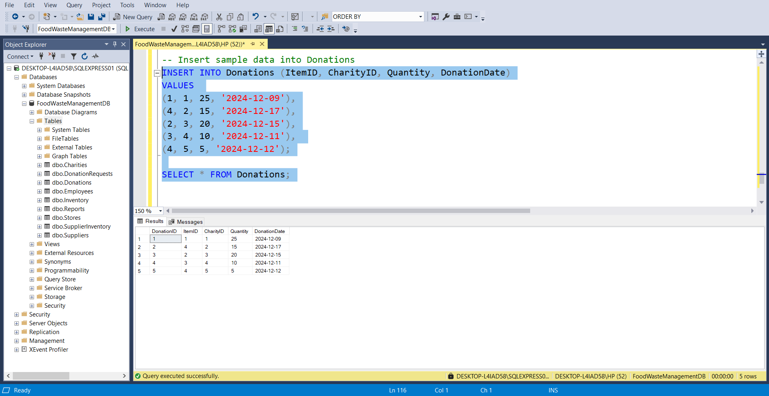

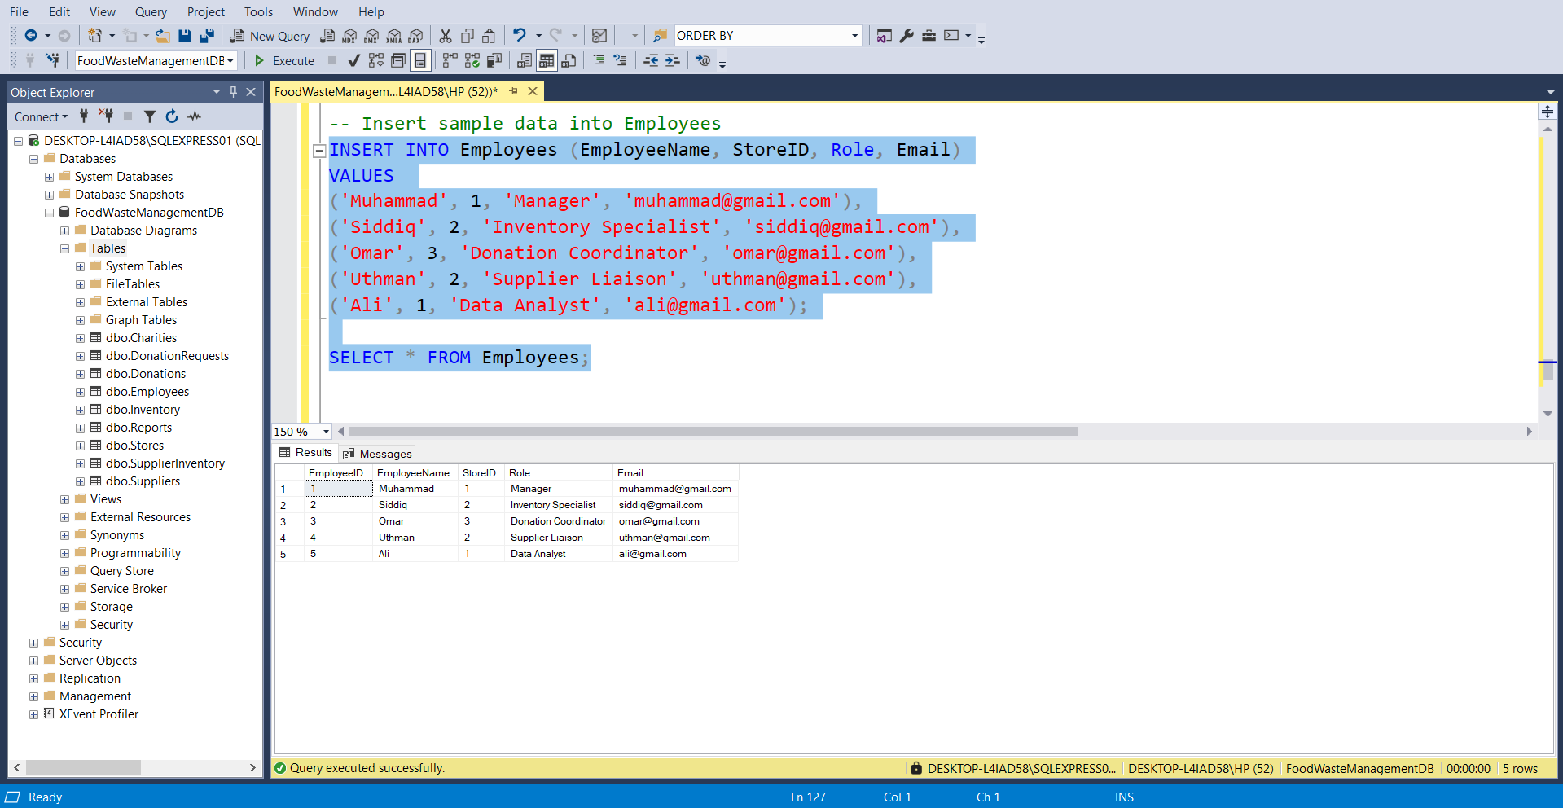

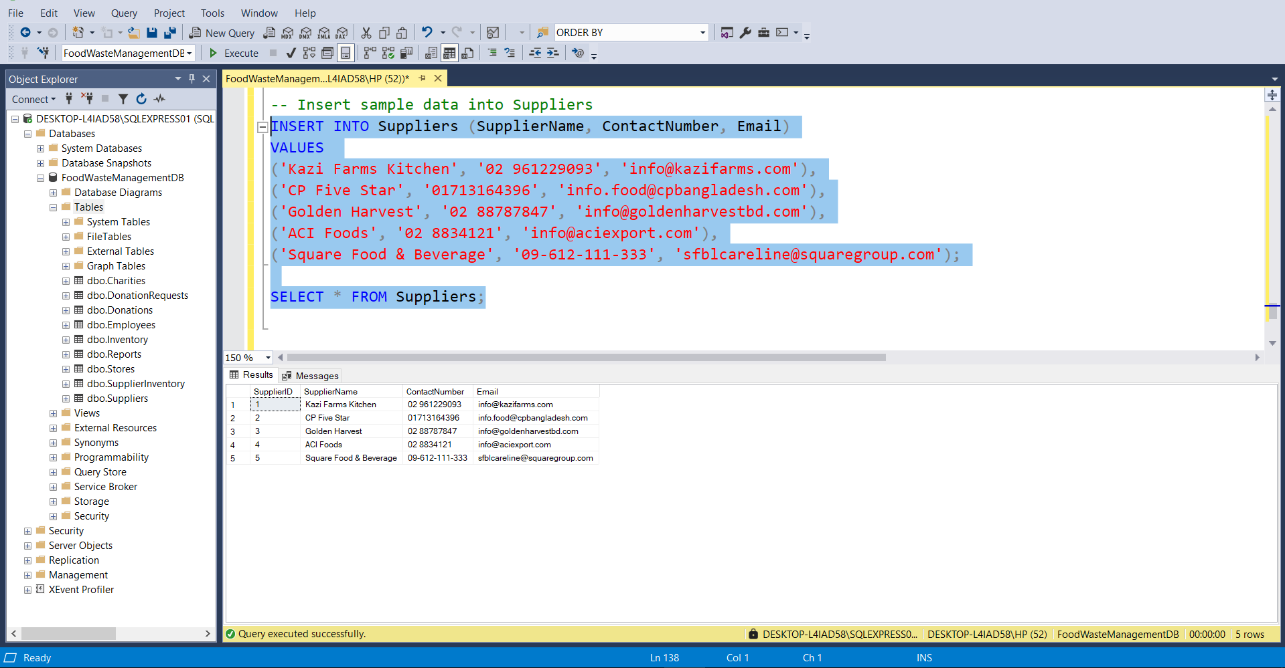

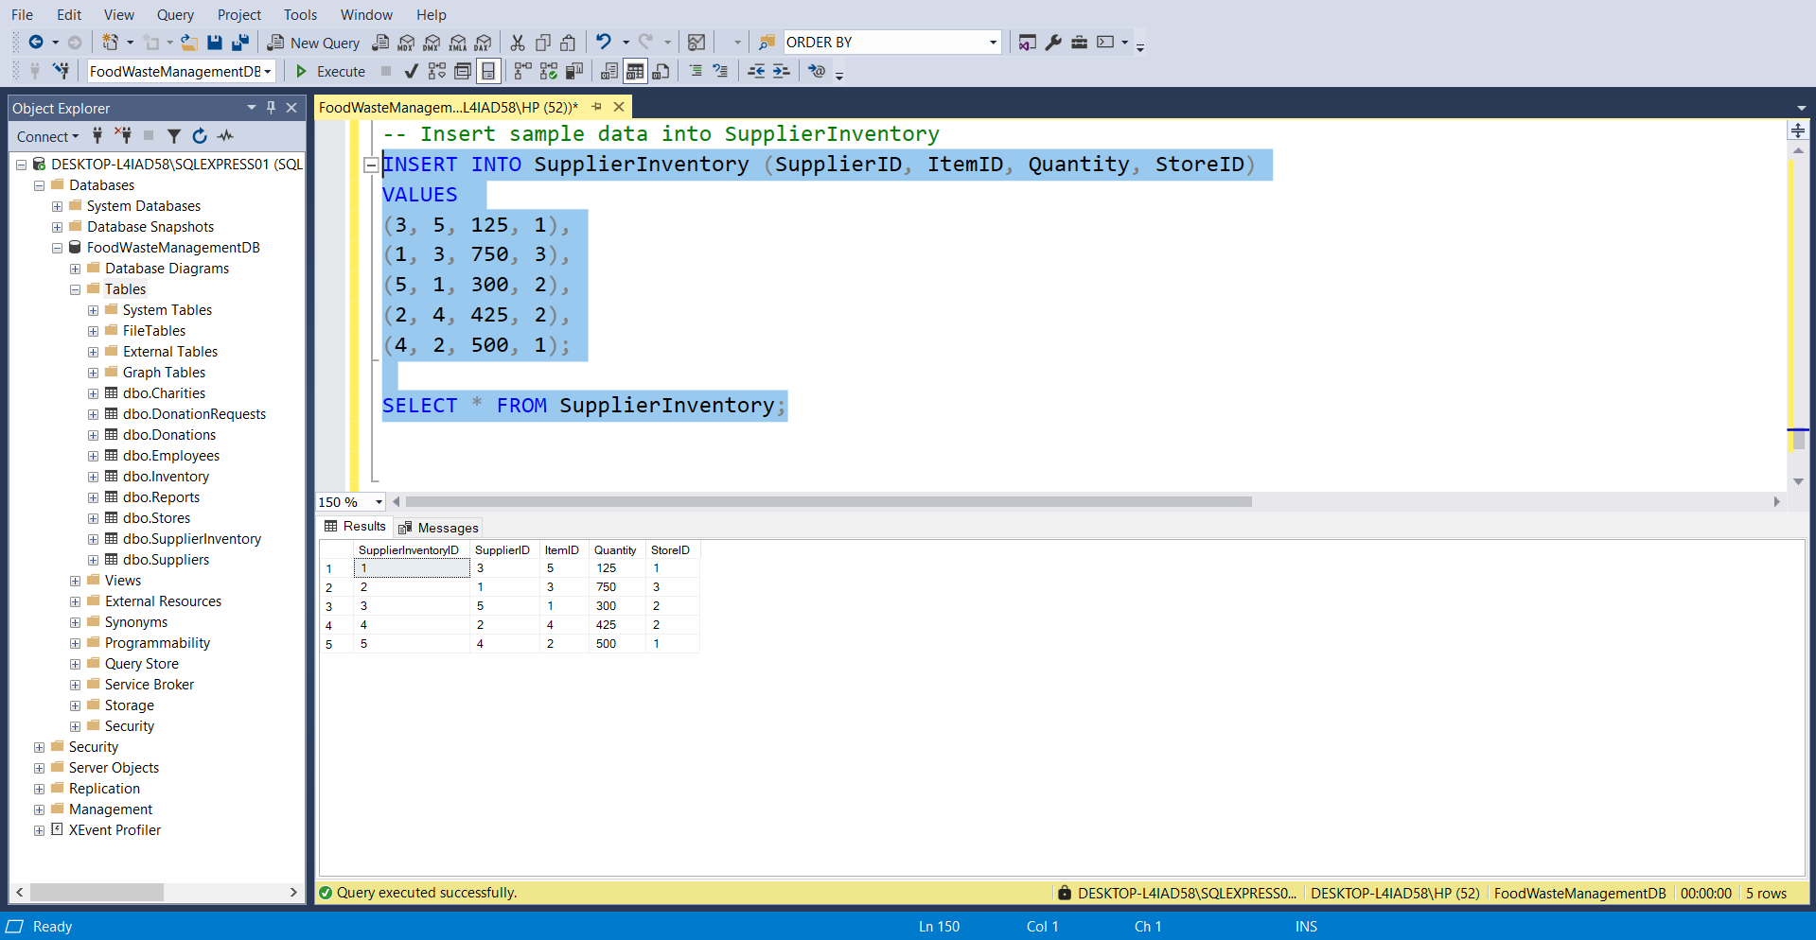

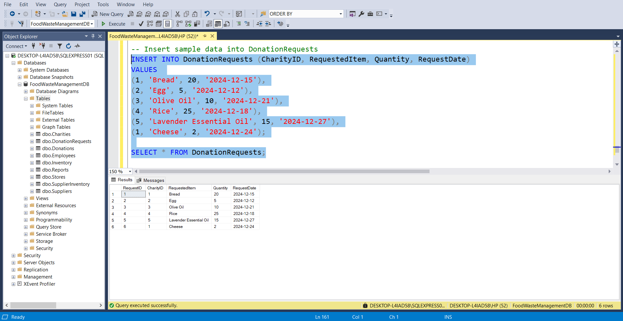

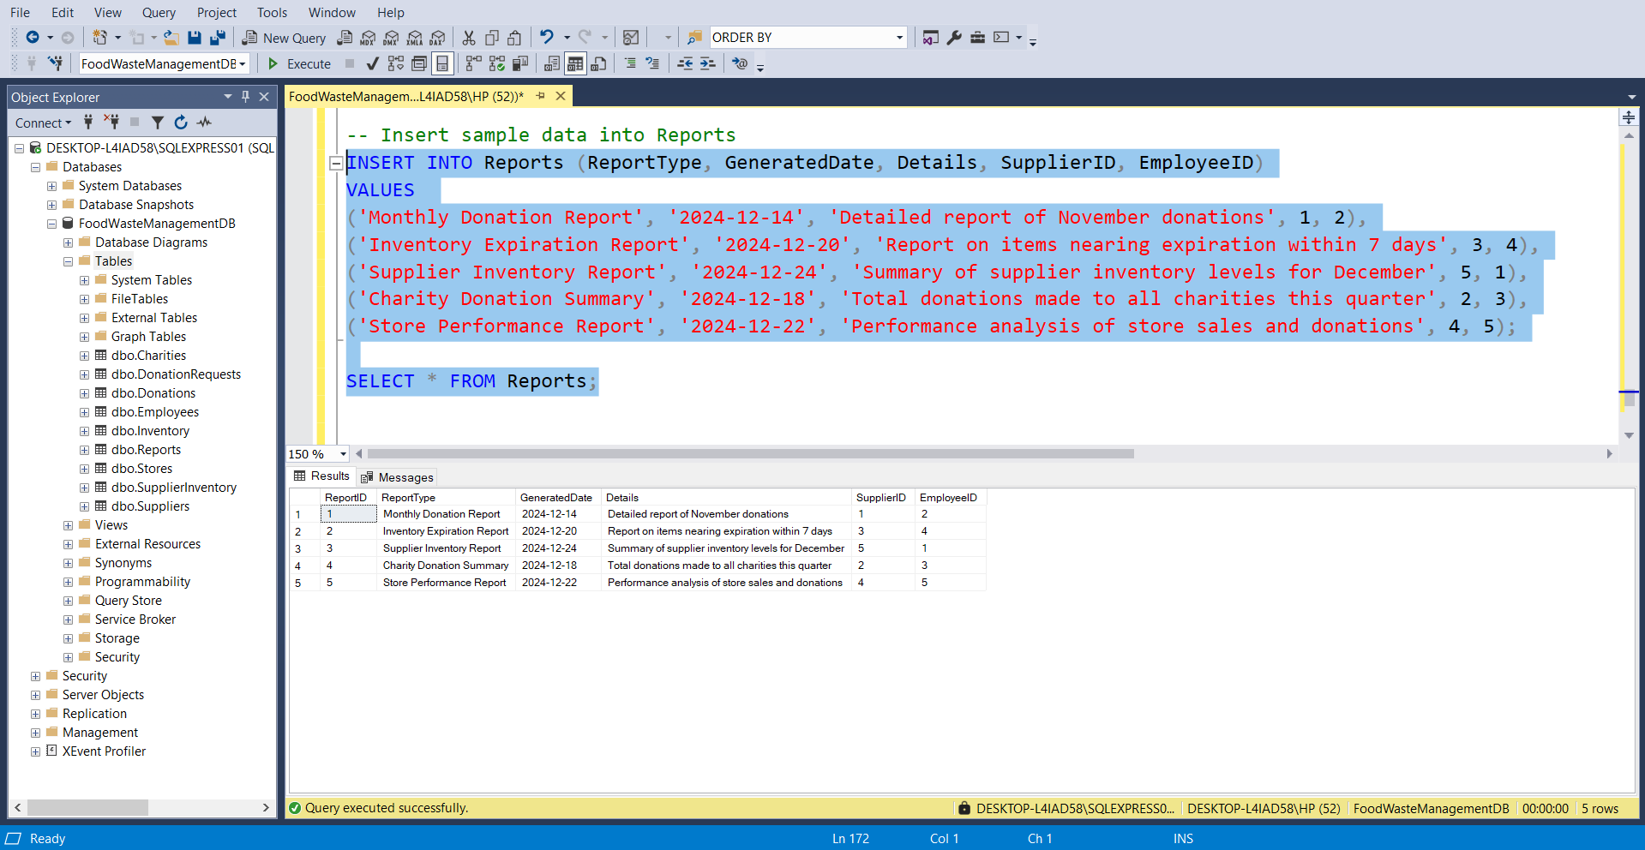

1. **SELECT Query:**

Retrieves data from tables for display or analysis.

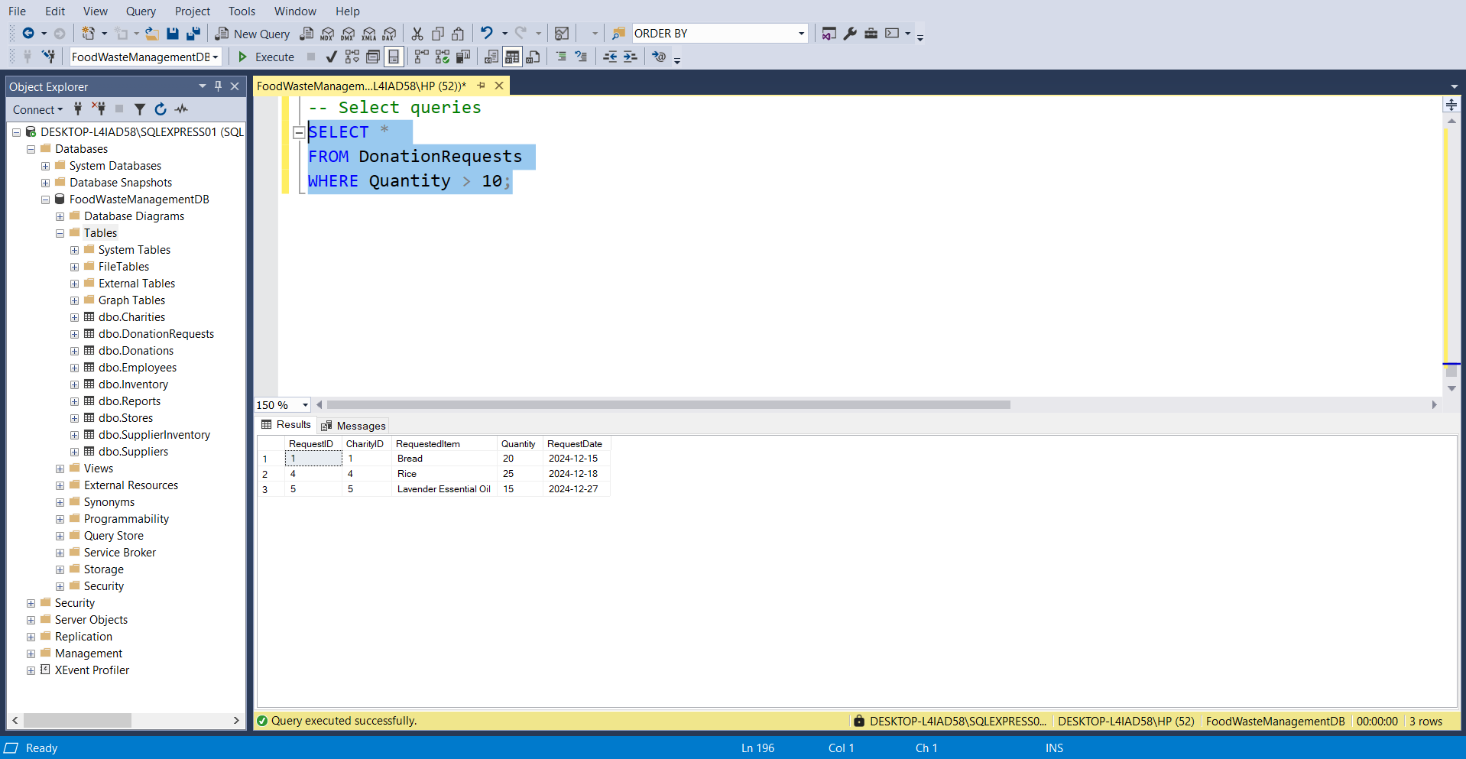

1. **UPDATE Query:**

Modifies existing records in the database.

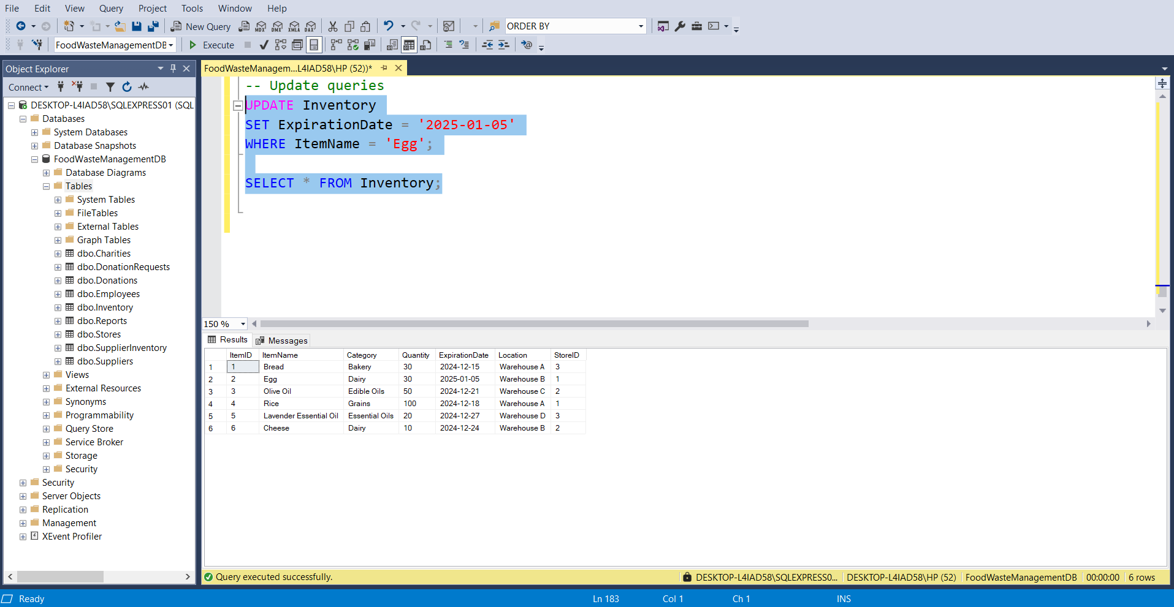

1. **DELETE Query:**

Removes specific records from a table.

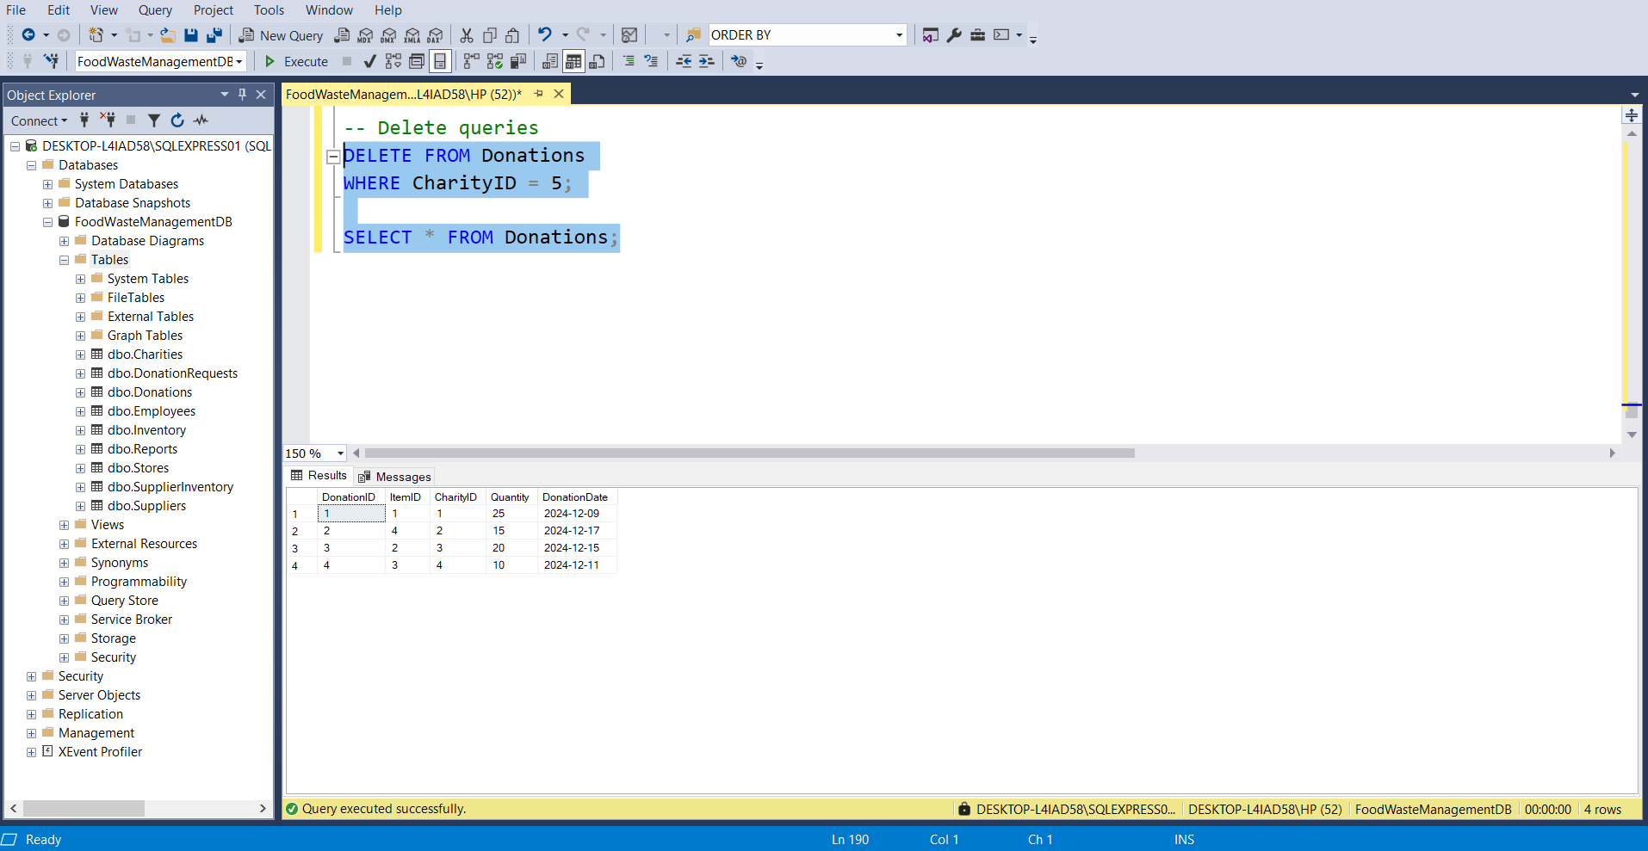

1. **ORDER BY Query:**

Sorts results based on one or more columns.

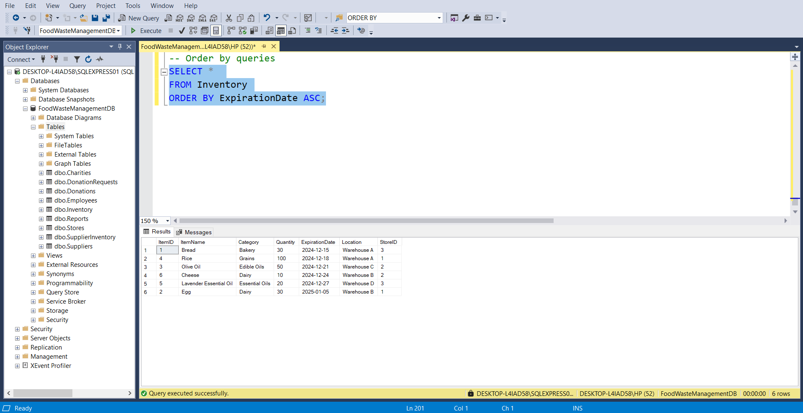

1. **MIN and MAX Functions:**

Calculates the minimum or maximum value of a column.

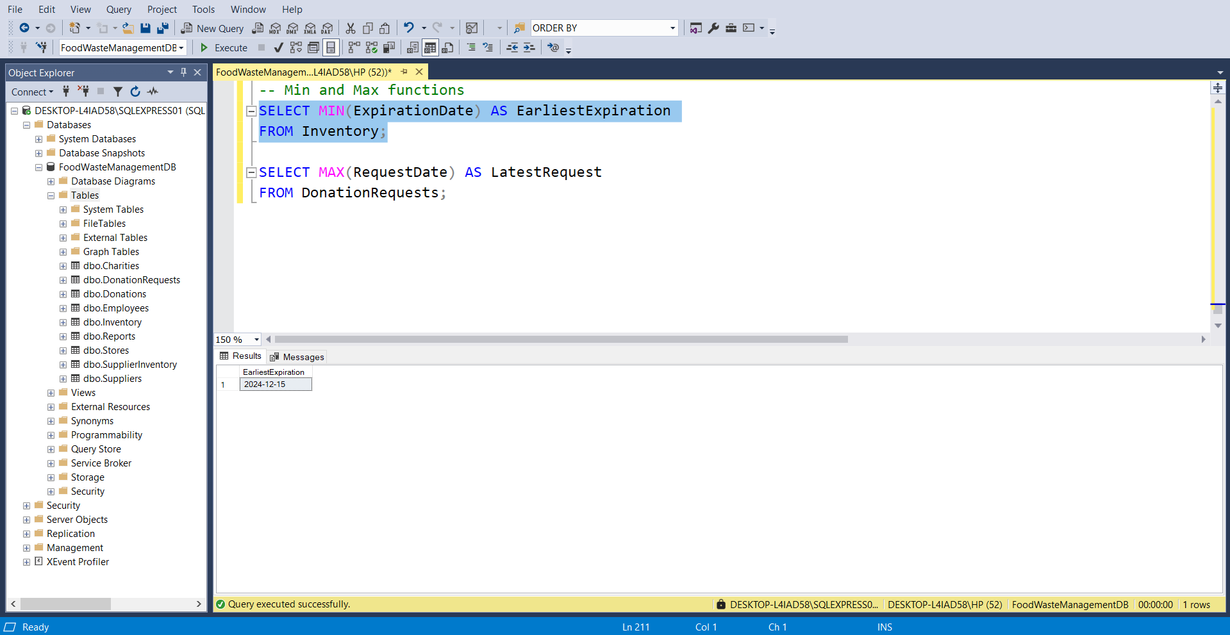

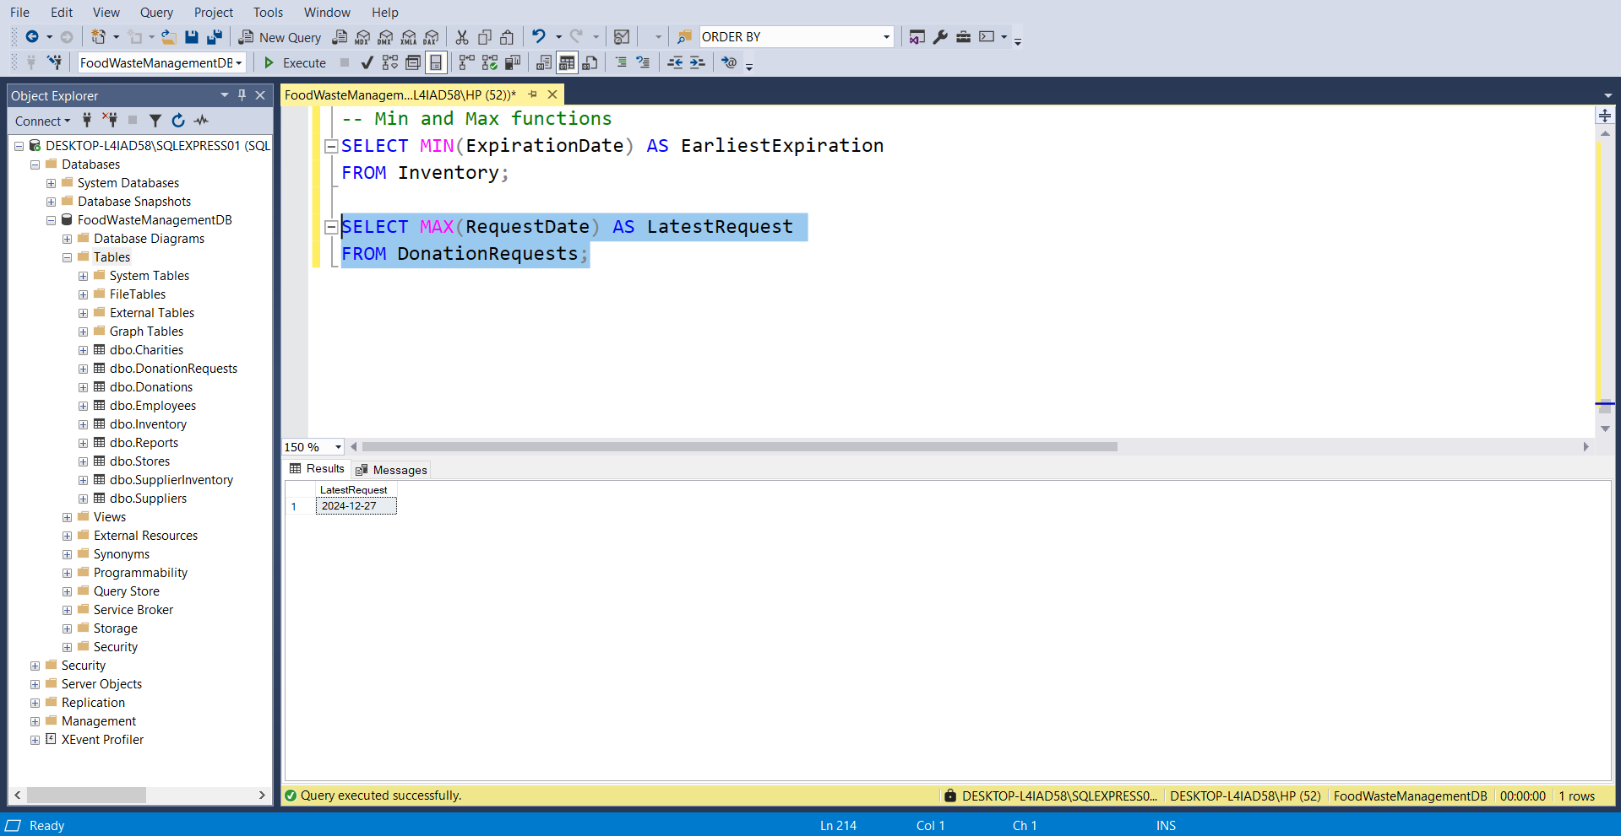

1. **COUNT Function:**

Counts the number of rows that meet certain conditions.

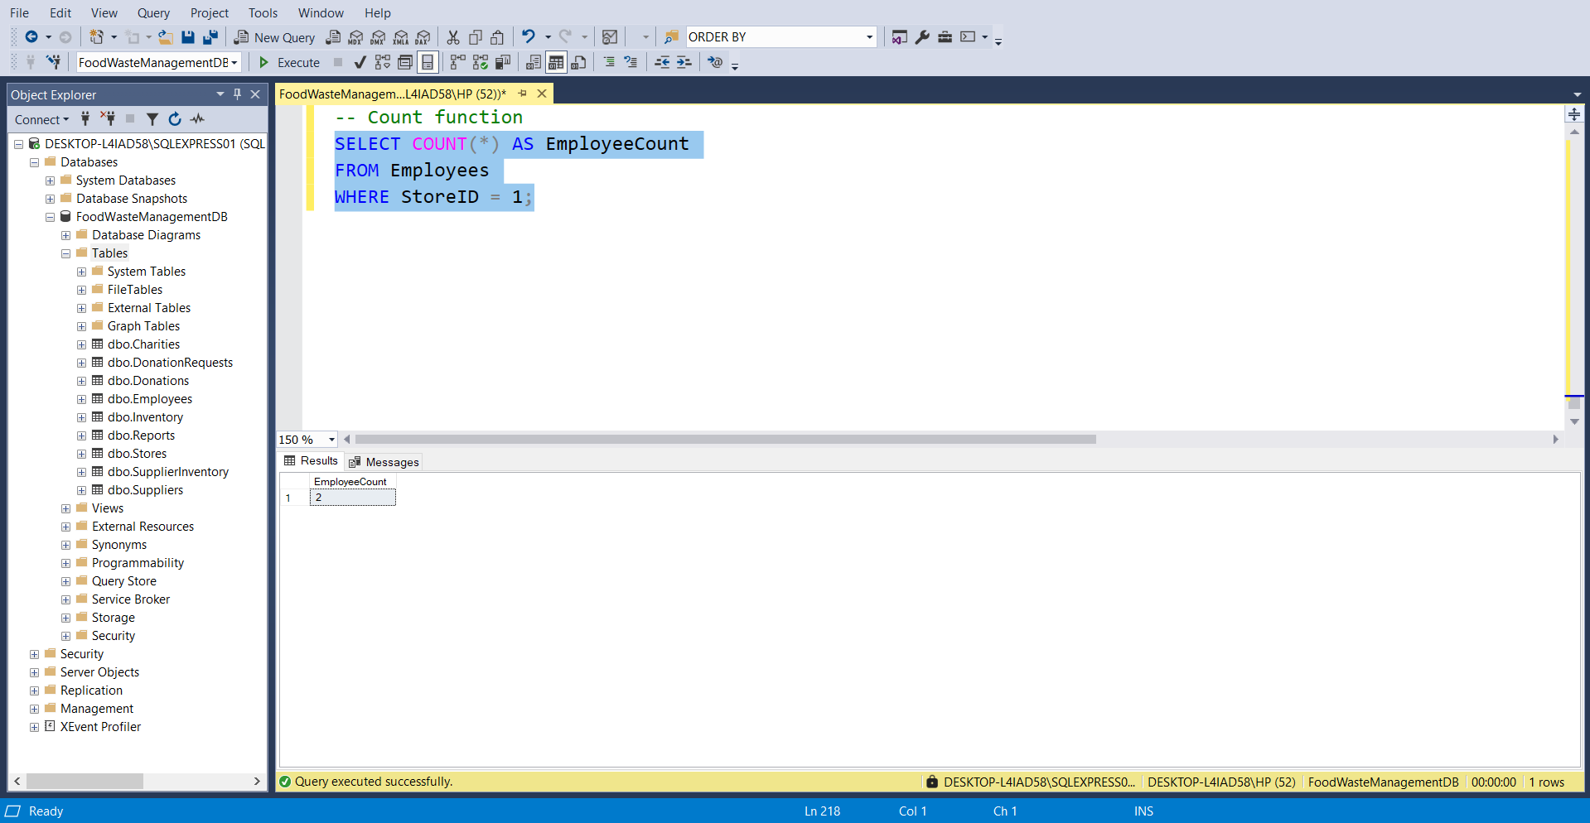

1. **SUM Function:**

Calculates the total of a numeric column.

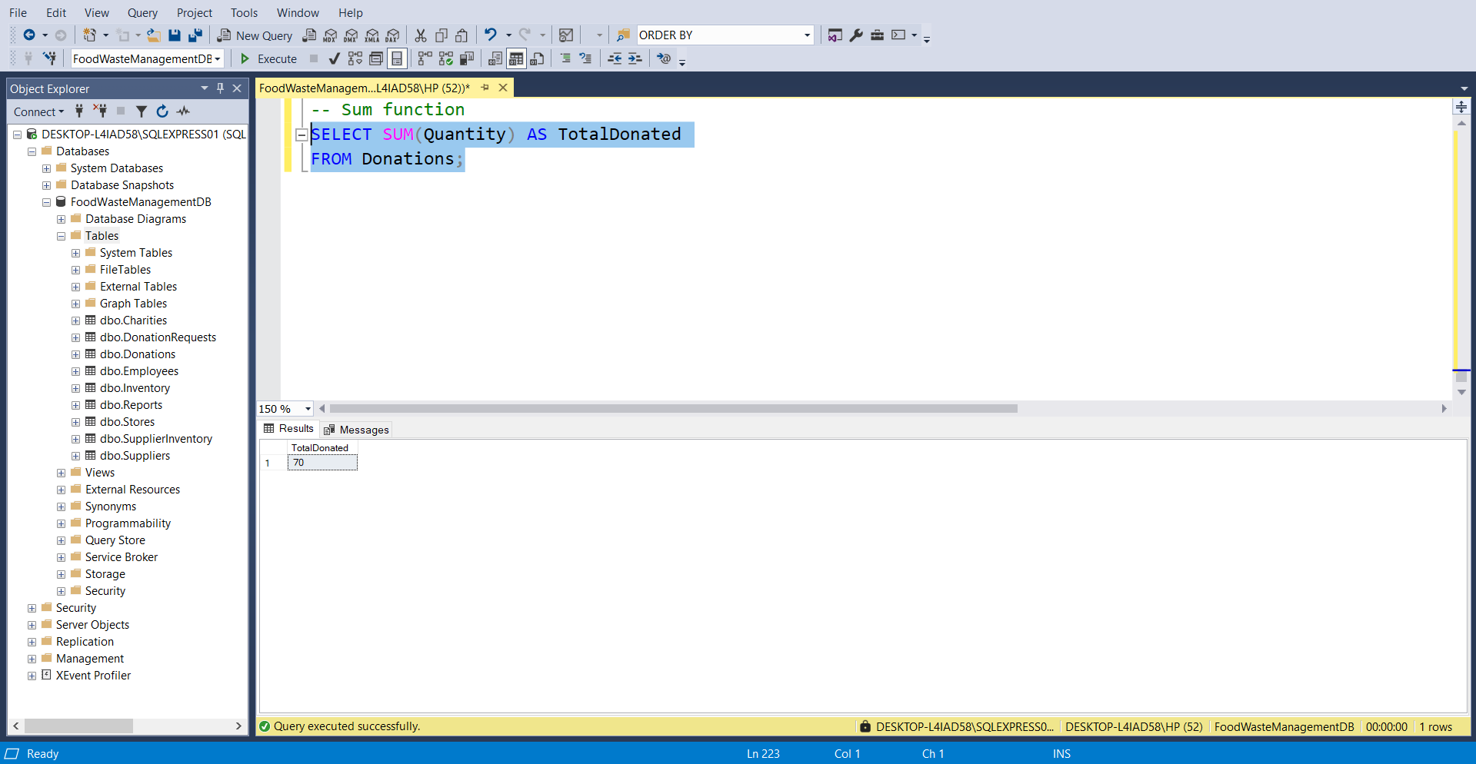

1. **AVG Function:**

Finds the average value of a column.

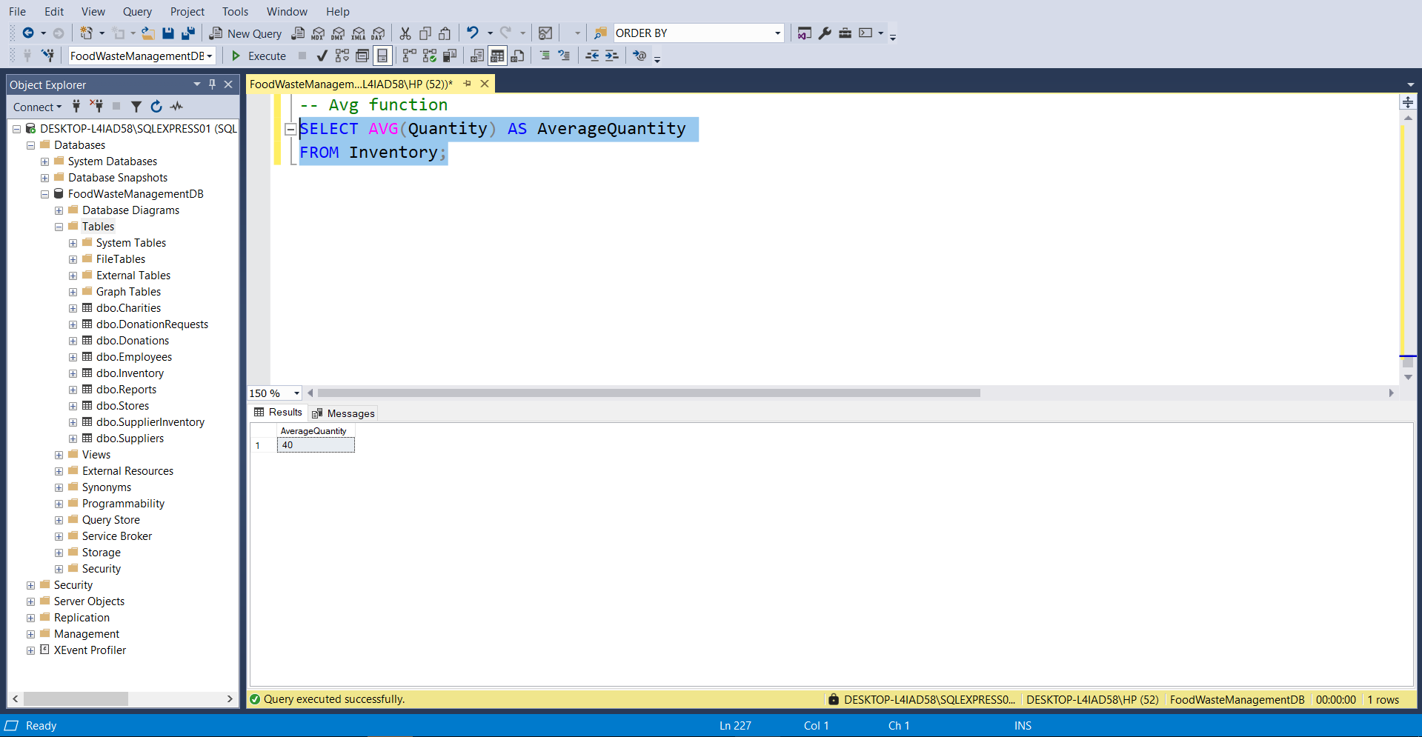

1. **LIKE Operator:**

Searches for patterns in string data.

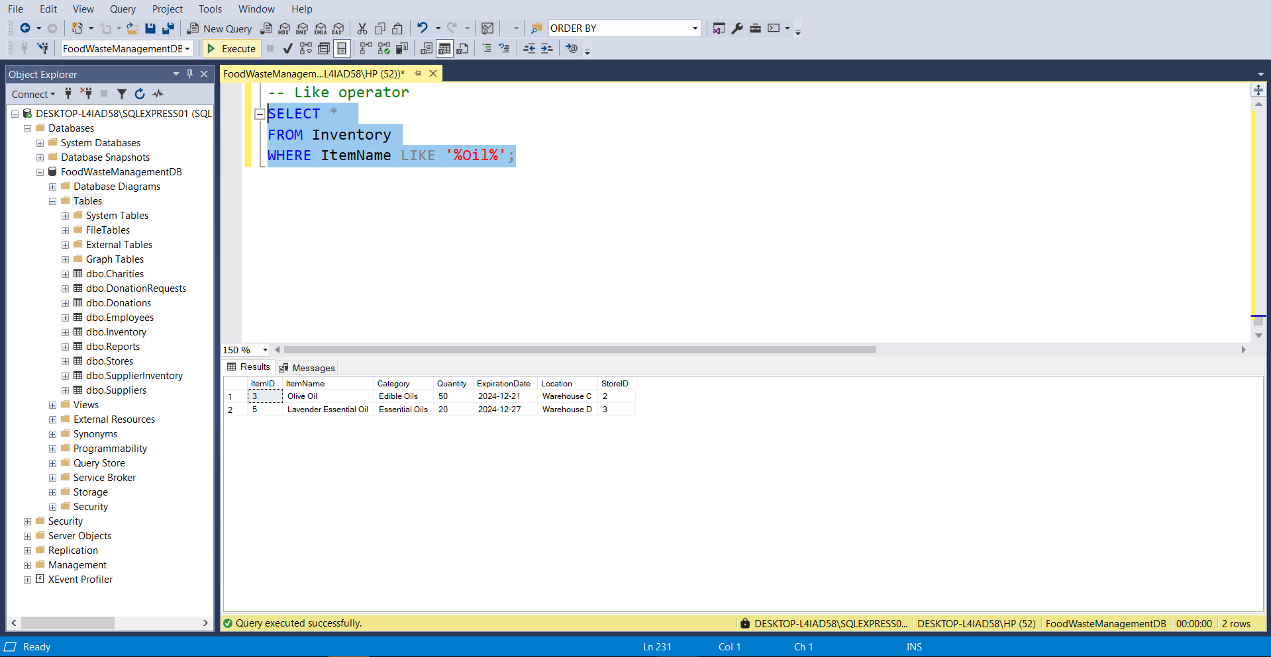

1. **JOIN Queries:**

Combines data from multiple tables.

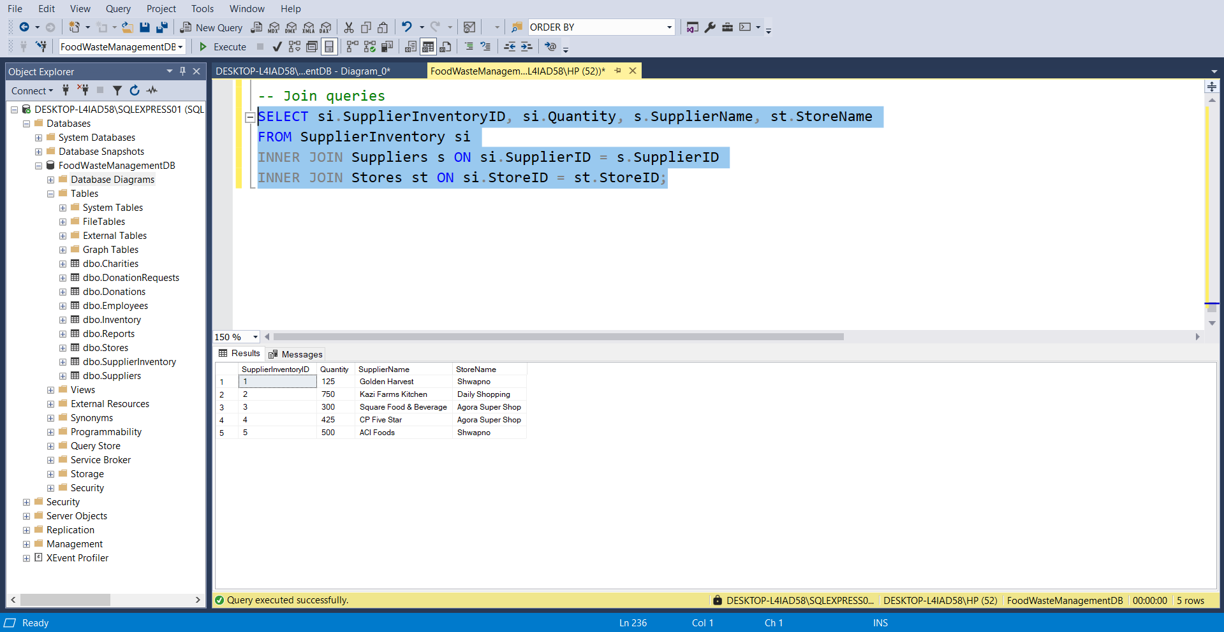

1. **INNER JOIN:**

To retrieve items that have been both donated and received by a charity, for tracking purposes.

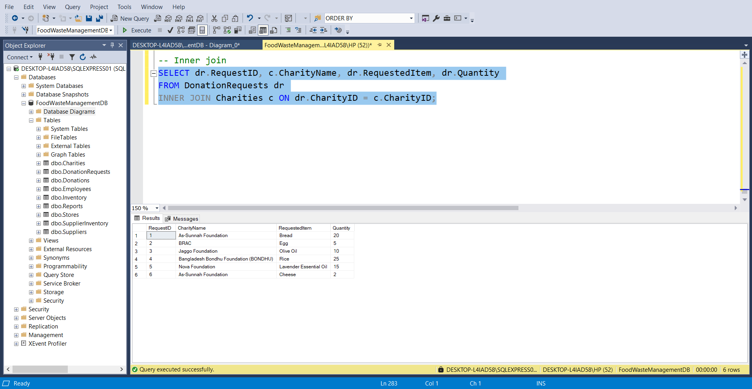

1. **LEFT JOIN:**

All items from the Inventory table, including their associated supplier information from the SupplierInventory and Suppliers tables. It ensures all inventory items are listed, even if no supplier is linked to them.

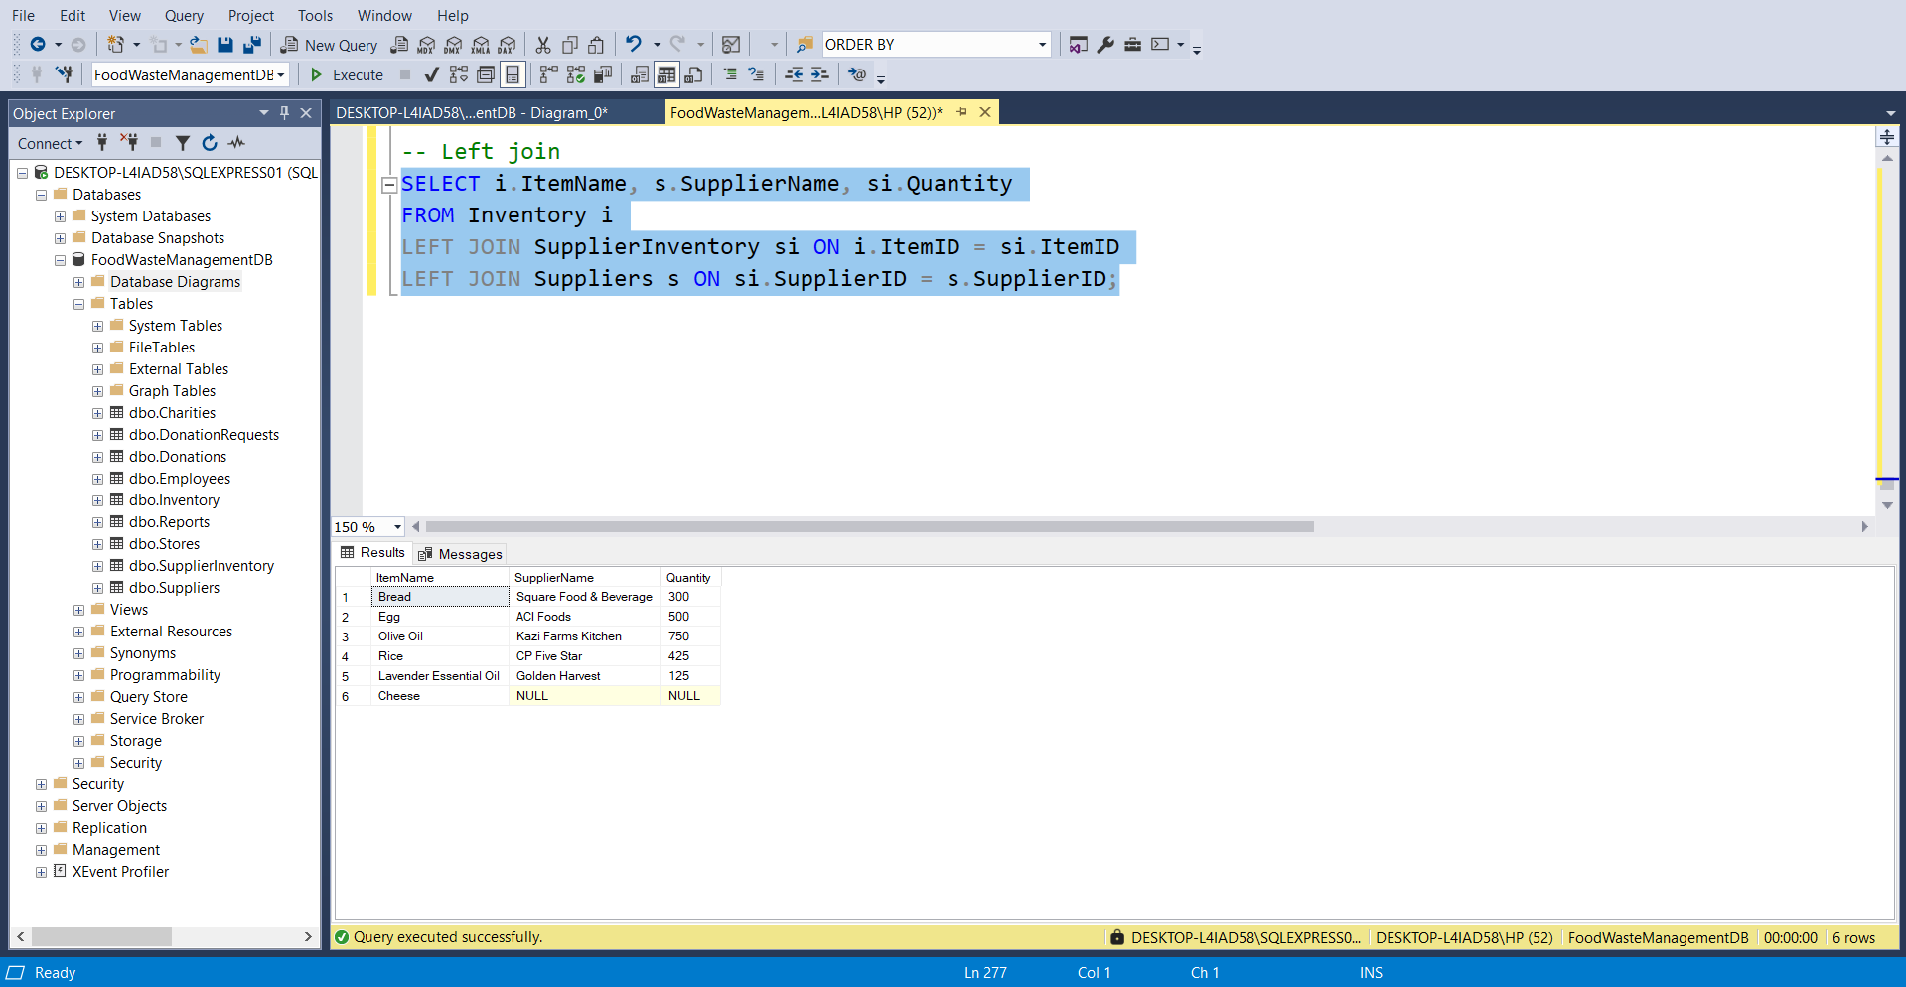

1. **UNION Query:**

Combines results of two SELECT queries into a single result set.

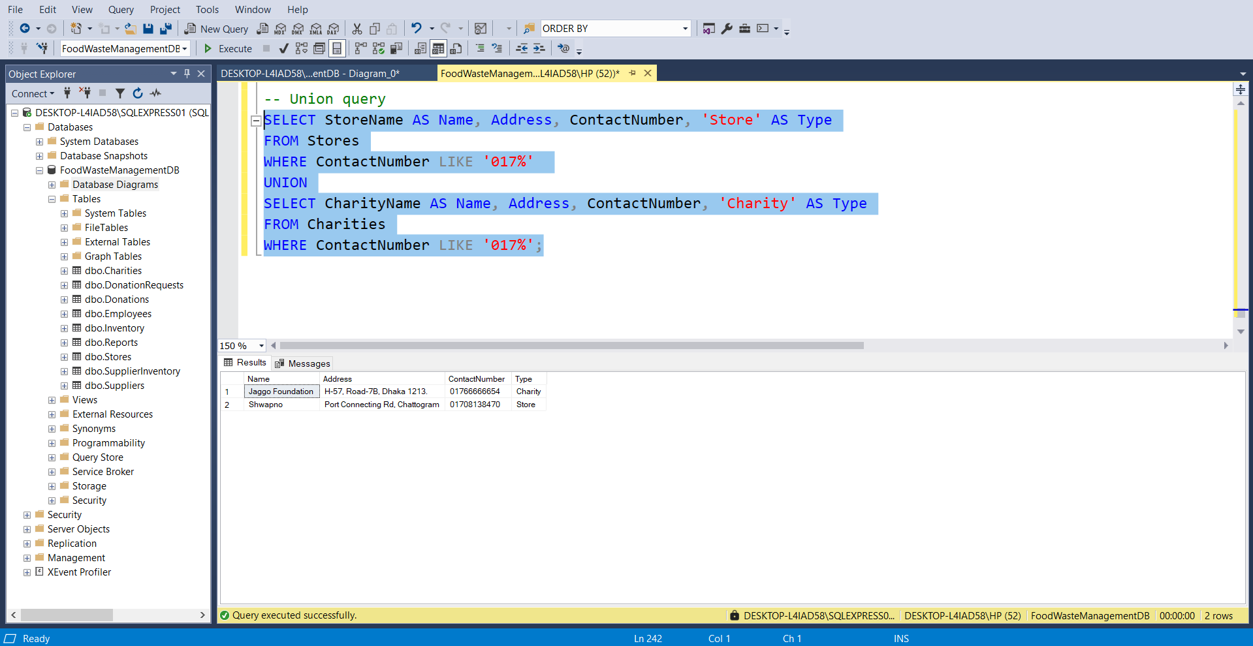

1. **DISTINCT Query:**

Retrieves unique values from a column.

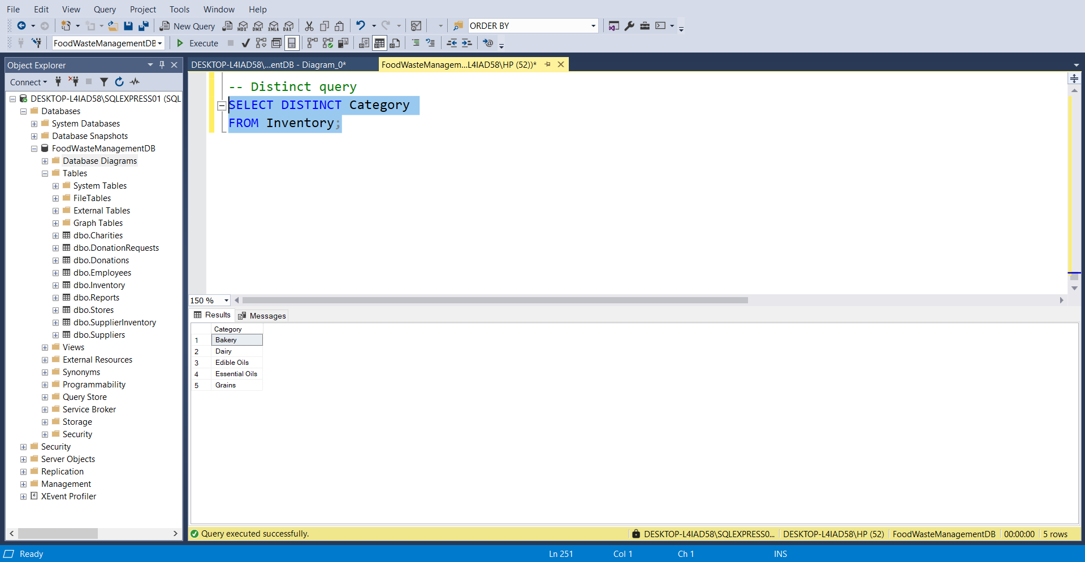

1. **EXISTS Query:**

Checks for the existence of records that meet a condition.

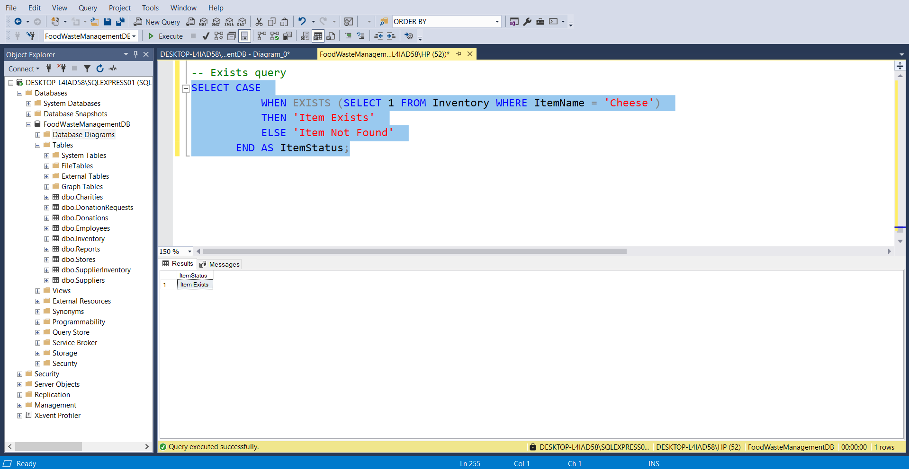

1. **CASE Statement:**

Applies conditional logic in SELECT queries.

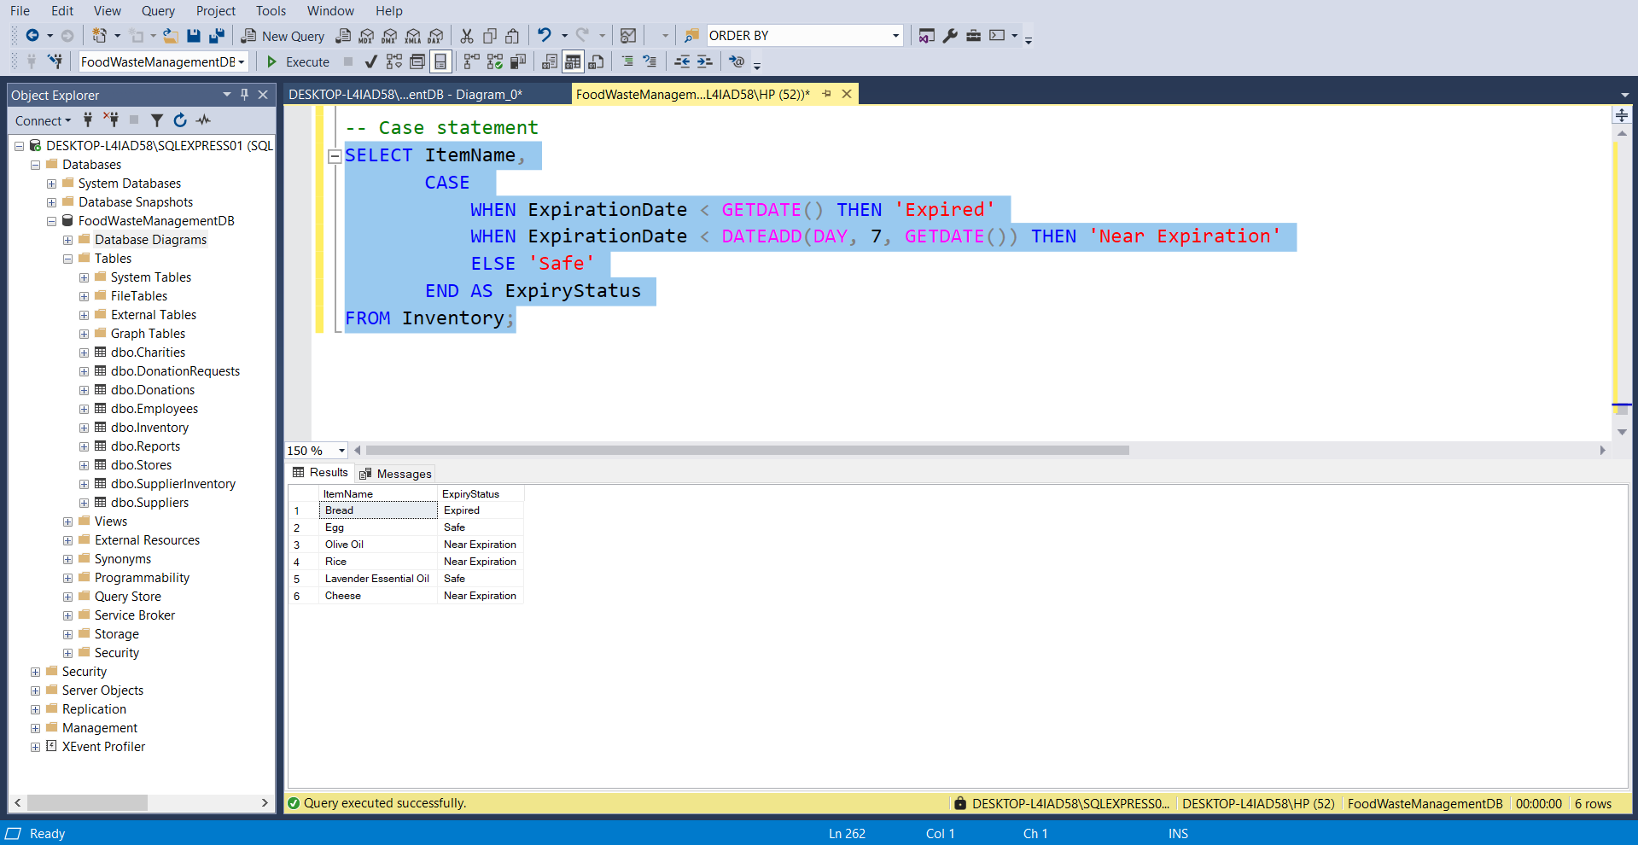

1. **HAVING Clause:**

Filters aggregated data.

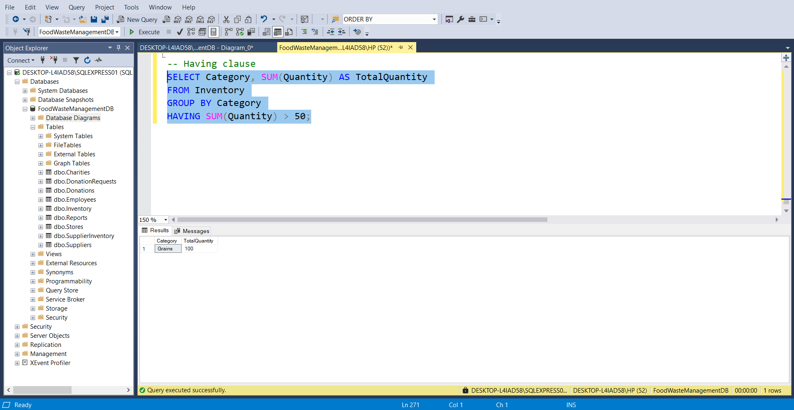

1. **GROUP BY Query:**

Groups data for aggregation.

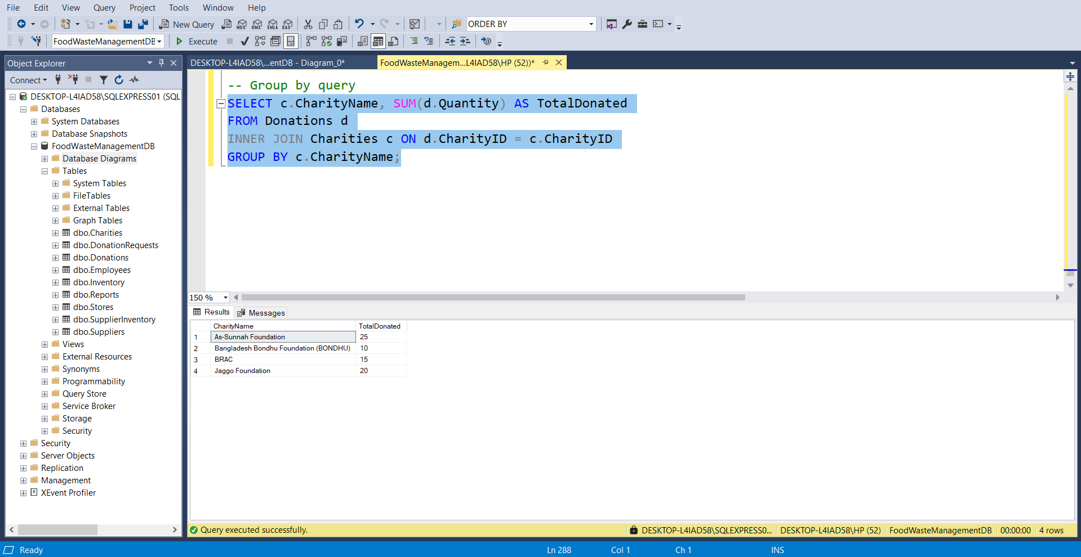

***DATABASE DIAGRAM***

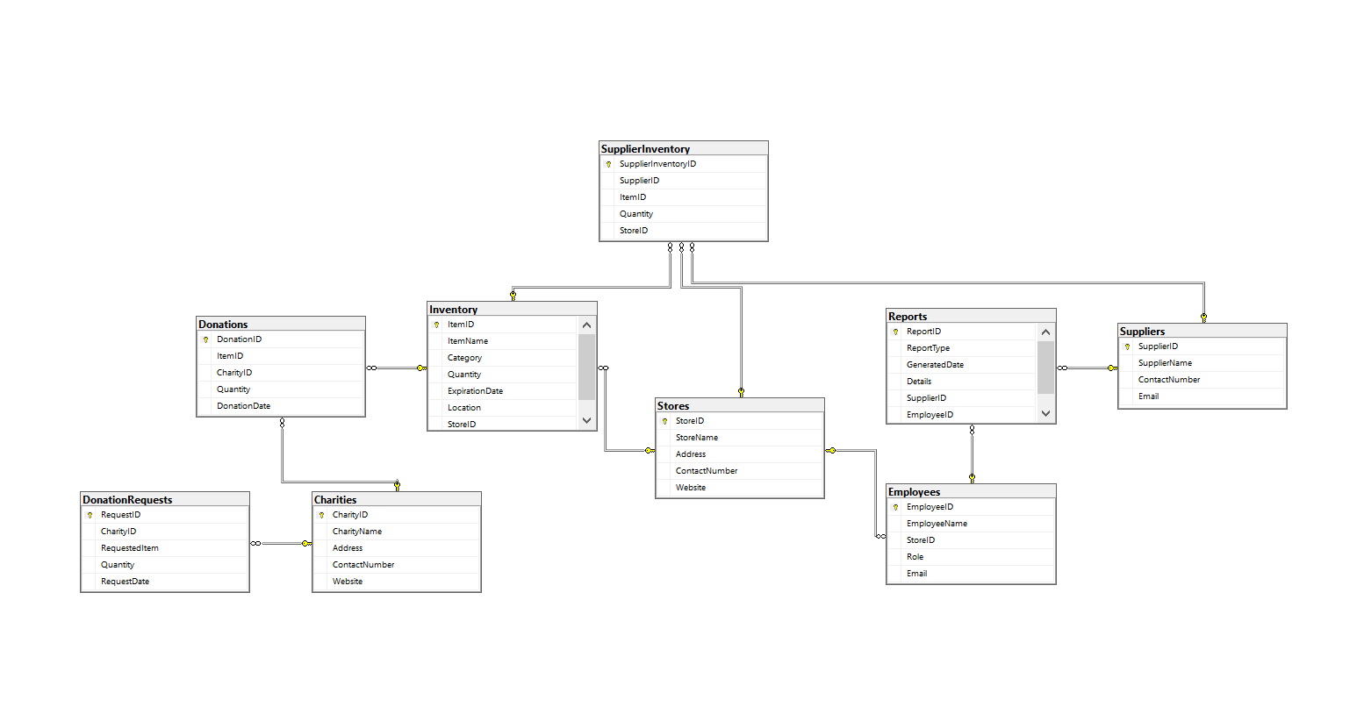

***Conclusion:***

The **Food Waste Management Database System** successfully addresses the need for efficient tracking and management of food inventory, donations, and related operations. By leveraging relational database principles, this system optimizes data retrieval, enhances decision-making, and ensures smooth coordination between stores, suppliers, charities, and employees. The use of structured SQL queries, including joins, aggregations, and conditional statements, demonstrates the system's ability to generate valuable insights, such as inventory status, donation summaries, and performance reports.

Overall, this project highlights the importance of technology-driven solutions in reducing food waste and improving resource allocation, paving the way for a sustainable and organized food management process.

***References:***

1. **"Food Waste Management: Modern Solutions and Strategies",**<https://www.foodwastejournal.com/articles/modern-solutions-strategies.html>  
   Last visited: 20/3/2024.
2. **"Designing Databases for Food Management Systems",**<https://www.databasedesignguide.com/features/food-management-database.html>  
   Last visited: 25/3/2024.
3. **"SQL for Inventory and Donation Management Systems",**<https://www.sqlresources.com/articles/sql-inventory-donation-management>  
   Last visited: 2/4/2024.
4. **"Charity Donation Systems: Efficient Tracking and Reporting",**<https://www.donationtrackingsystems.com/charity-tracking-solutions.html>  
   Last visited: 6/4/2024.
5. **"Optimizing Inventory Systems for Waste Reduction",**<https://www.optimizedinventory.com/resources/waste-reduction-strategies>  
   Last visited: 10/4/2024.